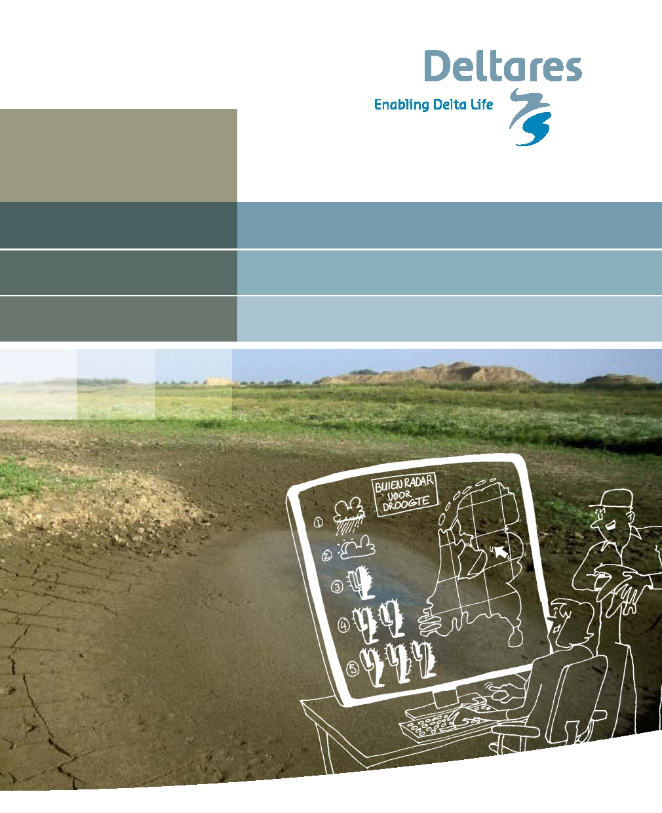
Costing drought:
innovative approaches to water scarcity



2 Flood Risk Management


Costing drought:
innovative approaches to water scarcity

2 Flood Risk Management


Foreword

Water management in the Netherlands is, on the whole, up to standard. We are safe and we have enough water that is also relatively clean. However, against a background of climate change, sea-level rise and land subsidence, it is fair to ask whether this situation can be maintained. The latest climate scenarios suggest that persistently dry, warm summers may be more frequent in the Netherlands in the future and lead to water scarcities. Nevertheless, this is not just a challenge for the future, as we discovered during the summers of 1976 and 2003. It is important for us to make sure that our water management regime is in order so that we can cope with the developments awaiting us. Problems in the area of flood protection, freshwater supplies, salinisation and changes in water use require new solutions. Creativity and innovative thinking are key here.

At the initiative of WINN (Water Innovation Rijkswaterstaat Centre for Water Management and Deltares), the theme 'Drought' was adopted as the starting point for an inspirational booklet about drought innovations. The easy-to-read booklet sketches a range of innovative measures that may inspire people to tackle drought challenges. It does not aim to provide all the answers, focusing instead on a concise overview of concrete, and less concrete, ideas.

The title is "Costing drought", which may sound slightly dull, but this booklet describes the dynamic possibilities awaiting us in the future of water management. So I sincerely hope it will inspire water managers at Rijkswaterstaat, water management authorities, provinces, municipalities, NGOs and businesses, and make a contribution in that way to our shared commitment to the constructive and innovative development of the Delta Programme.

I wish you all an enjoyable read.

Rein van der Kluit
Chief Engineer-Director of Zeeland Rijkswaterstaat, and sponsor of the
Water Risk Management Cluster of the Rijkswaterstaat Corporate Innovation Programme



Contents

1
23456789
10 11 12 13 14 15 16 17 18 19 20

Introduction
Water tankers
Strategic water storage at depth
Serious gaming
Eco-labelling with water footprints
Cross-boundary approach to drought and water scarcity
Drought-dependent water charges
Innovative desalination
Rainfall radar for drought
Drought ship
Water husbandry
Sensors to prevent drought damage
Wet and dry insurance
Limiting salt intrusion in estuaries
Inland shores
Underground hydraulic barrier
Drought sessions
Water from the shore
Bubble screens and other adaptations to locks
Level-controlled drainage
Keeping Fresh
Afterword
Abbreviations
References
Annex: Other drought measures
Credits

7
15 19 23 27 31 35 39 43 47 51 55 59 63 67 71 75 79 83 87 91 95 97 99
101 104



Introduction

Aims
The Netherlands faces problems caused by drought. Anybody who thinks of the Netherlands as a country where there is regular rainfall in a predominantly green landscape and abundant surface water will find this difficult to imagine. But it is true nonetheless. And droughts in the future are expected to be longer and more frequent because of climate change.

The aim of this booklet is to inspire water managers and other water stakeholders to tackle the problem of drought together, and to devise creative, sustainable and effective solutions. Water stakeholders include agriculture, inland shipping, nature management, drinking water suppliers and other sectors that depend on water, such as industry and recreation.

We will turn the spotlight on a range of inspiring innovations in the area of drought. Those innovations vary from measures that have proven their worth in other countries but that are still unknown here, to innovative Dutch technological gems that are still waiting for widespread application, or ideas that are still in the early stages, and concepts that still require further elaboration.

Drought in our small wet country
What is drought? Meteorologists define drought as a period of significantly reduced rainfall in an area by comparison with the average for that period of time and that particular area. Hydrologists and water managers see drought as a period during which, as a result of a shortfall in water replenishment (due to inadequate rainfall and river flows), groundwater levels and discharge rates fall below a defined desirable level and water reservoirs fall empty. Farmers tend to see drought more as a period in which their land does not contain enough moisture, hindering crop growth. Socio-economic or societal drought is an unexpected but temporarily persistent

shortage of water of adequate quality, making it impossible to meet demand for water from agriculture and industry. There is also a risk of irreversible damage to the landscape and to nature.

In any case, the consequences of drought are felt in a lot of different ways. A lack of moisture in the ground can prevent crops from growing. A fall in the flow of groundwater into rivers can push ecosystems past a tipping point. Low water in primary water systems can interfere with the transportation of water and the intake of cooling water. Salt intrusion may cause the salinisation of surface water and groundwater. Peat oxidation may lead to land subsidence. Droughts are generally during the summer and the impact can be exacerbated by other factors such as heat and dust.

Drought, water scarcity and desiccation
We usually think of drought and a calamity or, at least, as an undesirable development lasting some time. Water scarcity is a structural imbalance between water consumption in a given sector or area, and the amount of water of a given quality that is available and accessible there. Although drought and water scarcity are therefore not the same thing, and although they differ in terms of duration and level of predictability, they do have the same type of negative impact. In this booklet, which has been written to inspire you, we will not make a hard and fast distinction between drought and water scarcity; in both cases we will use the term 'drought'.

Desiccation is not the same as drought. Drought is a temporary, recurring phenomenon (varying from weeks to years) in which there is less rainfall than usual. Desiccation involves damage to nature as a result of the extraction of water from the subsurface for agriculture and, for example, drinking water. Unlike drought, desiccation is a structural phenomenon.

Drought and water scarcity in the Netherlands, now and in the future
Overall, the Netherlands is a water-rich country. We use less than 20% of the fresh water entering our country. Our available supplies of water are so large mainly because the Rhine and the Meuse bring in so much. Without this constant flow, the situation would be completely different. However, on a smaller scale, we do see water scarcity. The salinisation of water in some parts of the Southwestern Delta is already such that there are structural limitations on agriculture.

The Netherlands has known droughts on a number of occasions in recent decades, with 1976 and 2003 as notable examples. On the basis of studies^{1,2} (the literature can be found at the back of the booklet), we assume that extremely low water levels in undammed sections of the Rhine and Meuse rivers, in local waters, and also in groundwater in higher parts of the Netherlands (as in the year 2003) will be annual occurrences by about 2050. Model studies^{3,4} indicate that, if land use does not change, salinisation of the groundwater will increase in some areas in South Holland because of predicted sea-level rise, land subsidence and changes in net groundwater recharge.

And learning from other countries…
Everybody has seen pictures of warm and dry areas, generally in developing countries, where crops fail as a result of drought, cattle die and people are forced to flee in search of a better life. Closer to home, drought is a more common phenomenon, too. The frequency of drought and water scarcity in Spain, Greece and other Mediterranean countries is on the rise. These countries have had to cope for longer and more often with drought and water scarcity. Here in the Netherlands, we can learn from their experience.

However, the climate, the subsurface and water management in these drought-sensitive countries are not the same as in our country. This is particularly true of the low-lying part of the Netherlands and its polders. In our survey of drought innovations, we deliberately looked at the measures frequently adopted in other countries. We confined our selection to those innovations that we thought would be appropriate for the Dutch context.

Possible solutions for drought innovations
As pointed out above, the drought innovations we present here cover a wide range of possible measures; our aim is to inspire different approaches to drought problems.

Demand and availability
To classify the different drought innovations, we distinguish between the various aspects that are relevant to tackling drought problems. For example, we distinguish between measures focusing on boosting water supplies and measures that actually reduce water demand. On balance, both types of measure reduce drought sensitivity and water scarcity.

Hard and soft
We also make a distinction between hard and soft measures. Hard measures require changes in spatial planning, and technological and infrastructural improvements and implementation. Soft measures involve process-based activities that aim to raise awareness, changes in behaviour to manage water demand, and institutional changes so that people are better prepared to cope with drought.

Local and international
In addition, we can also break down drought measures on the basis of the scale of the processes that cause drought. Individual farmers faced with drought may be able to take steps at the local level to reduce their exposure to risk. Other measures actually require a regional or even international approach, for example involving the entire Rhine catchment.

Structural and emergency
As well as the spatial scale, we can also classify measures on the basis of the temporal scale. Drought is a temporary phenomenon and it is unpredictable, whereas water scarcity is structural and therefore more manageable. These differences require a difference in the attitudes and approaches adopted by water managers.

Opposition and acceptance
Finally, there is one last distinction. Do we want to fight drought by taking action, or are we prepared to accept drought? In the first case, technological and infrastructural changes will mainly be used to prevent drought or to protect functions against drought. In the latter case, adaptation to drought involves switching to functions that are less drought-sensitive, moving drought-sensitive functions to areas where there is no drought or less drought, or accepting drought as a fact of life and providing financial compensation for the damage it causes.

The figure on the next page lists the different drought innovations we describe and indicates what type of measures are involved.

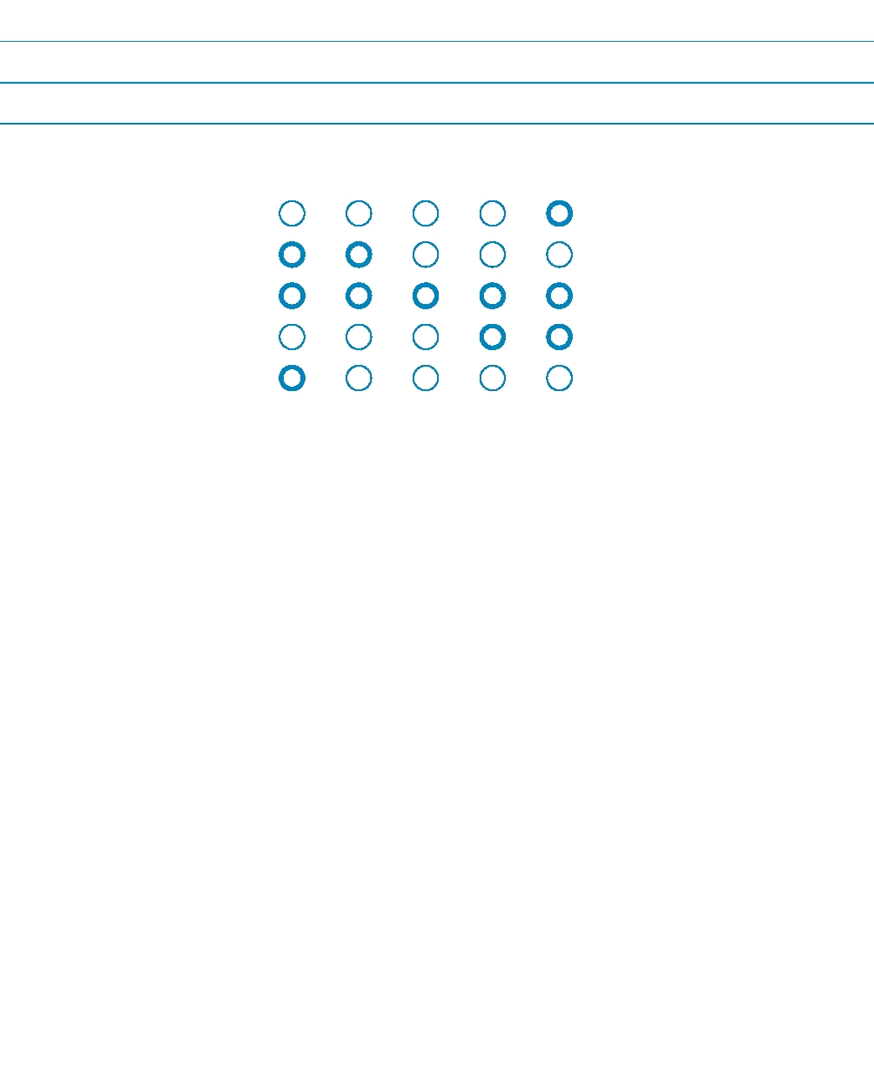
Strong Moderate Neutral Moderate Strong

Demand Availability

Hard Soft

Local International

Structural Emergency

Opposition Acceptance

The axes with circles describe the five categories we used to describe the measures. For example, water demand or water availability, hard or soft measures etc. A brief explanation is given below.

Demand:
Availability:
Hard:

Soft:

Local:
International:

Structural:

Emergency:

Opposition:
Acceptance:

focused on reducing water demand/requirements;
focused on boosting water supplies;
relates to the use/implementation of technology
or infrastructure;
relates to a non-technological product
(raising awareness, alliances, process);
in terms of spatial scale, focus on the plot level;
in terms of spatial scale, focus on national/international catchment/sub-catchment.
focused on the structural boosting of water
supplies or the structural reduction of
water demand/increases in water demand;
focused on managing temporary shortages
that may arise during a drought;
focus on combating drought and water scarcity;
accepting drought but compensation for the associated damage.

Of course, measures may be not be entirely hard or soft but a combination of the two. In that case, several circles have been coloured. When a particular category is not genuinely applicable to a given measure, no circle at all has been coloured. Drought insurance, for example, does not lead to either an increase in water availability or a reduction in water demand. The drought innovations have been classified carefully. We hope readers will feel challenged to examine our work and think about wider application.

Overview
This booklet contains twenty concise descriptions of drought innovations that have been selected in consultation with Rijkswaterstaat, the Government Service for Land and Water Management (DLG), the Dutch Agriculture and Horticulture Organisation (LTO), the inland shipping sector and the Unie van Waterschappen (union of water management authorities). The booklet describes a wide range of drought innovations that water management authorities can work with. The descriptions can be read separately from one another. The titles, the brief descriptions, the cartoons and the accompanying schematics will help you to read quickly and selectively.

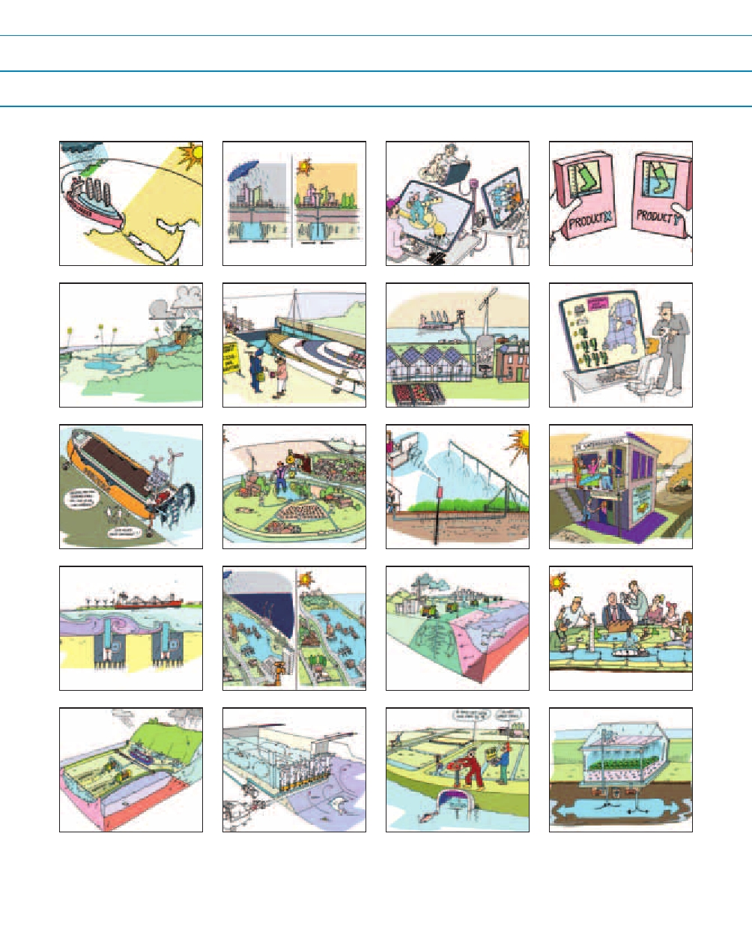
1 Water tankers

5 Drought action

9 Drought ship

13 Salt intrusion

17Shore

2 Water storage

6 Water rates

10 Water husbandry

14 Inland shores

18 Bubble screens

3 Serious Gaming

7Desalination

11 Sensors

15 Hydraulic barrier

19 Drainage

4 Eco-labelling

8 Rainfall radar

12 Insurance

16 Drought sessions

20 Keep Fresh

Introduction 13

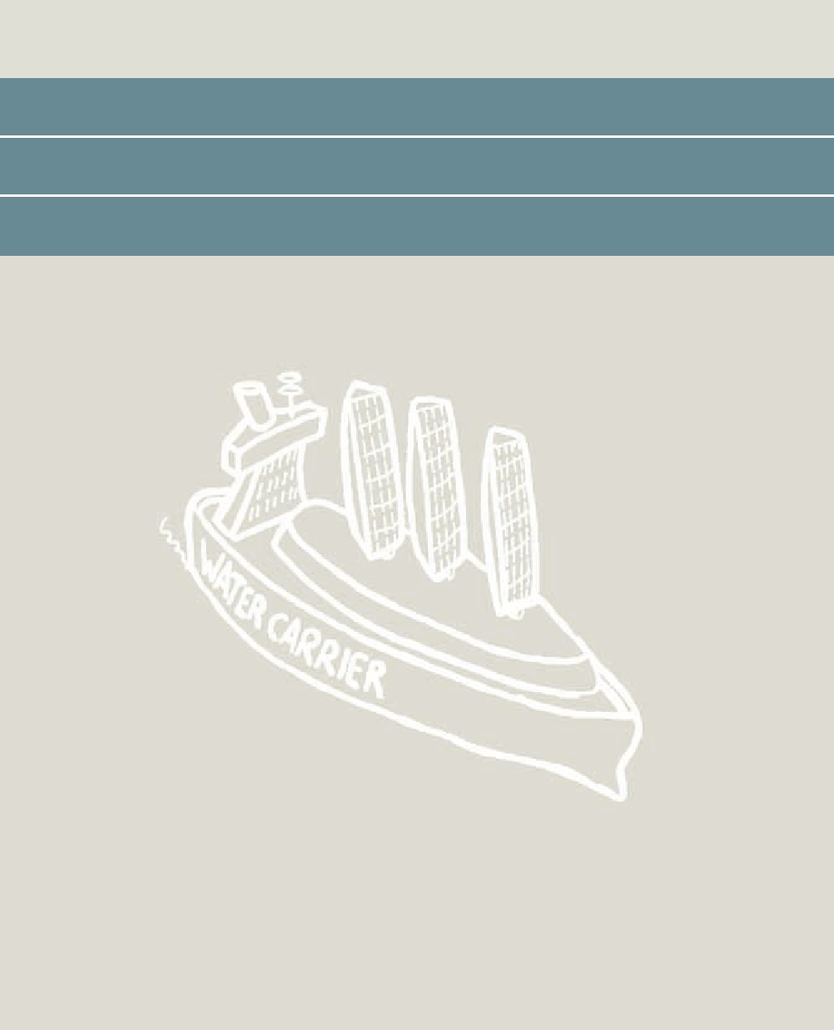

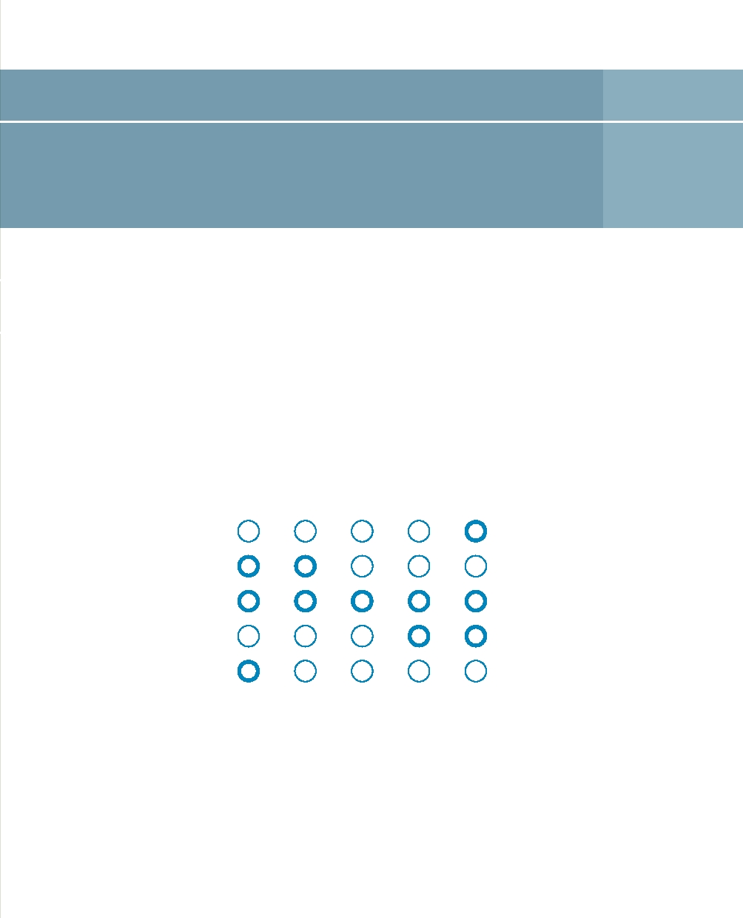
Water tankers 1

If drought is thought of as an urgent and unexpected problem with stocks, there can only be one solution: to move water from the place where there is too much water to the place where there is a shortage.

Principle
This drought innovation makes ad hoc use of improvised measures to cope with problems resulting from an unexpected drought. Anything you can use to transport water, such as tankers, railway rolling stock and water tankers, can be used to meet the acute and urgent demand for water.

Strong Moderate Neutral Moderate Strong

Demand Availability

Hard Soft

Local International

Structural Emergency

Opposition Acceptance

Case studies
In the spring of 2008, Barcelona was affected by a serious drought. Stocks from reservoirs upstream were exhausted and there was not enough drinking water for the residents and large numbers of tourists. Supplementing supplies from a river basin located nearby proved to be politically impossible. In the end, large quantities of fresh water were brought in by sea from Tarragona, Marseilles and a desalination plant in Almería. An expensive solution! It cost 22 million euros to transport 2.6 million cubic metres. That is 8.5 euros per cubic metre of drinking water. By comparison: one cubic metre of drinking water in the Netherlands costs approximately 1.45 euros.

We have also seen examples of bulk transportation closer to home. In April 2007, farmers in Zeeland used rented tankers to transport large quantities of water from West-Brabant in response to the sudden drought during the vulnerable start to the growing season. The costs amounted to approximately five euros a cubic metre. Apparently, even at such a high cost, the urgent demand justifies this type of bulk transport. In Alaska there are even commercial plans to take water from the Blue Lake to India and the Middle East using water tankers or large, floating, polythene sacks. The success of these bulk transports depends not only on a simple cost-benefit analysis but also on all sorts of national and international export regulations and, last but not least, adequate public support.

Applicability in the Netherlands
Generally, the Netherlands has a positive water balance and a good harbour infrastructure. The Netherlands may be able to supply 'blue services' with water tankers and open up the European rail network to countries with severe drought problems. It would be of interest to know whether it is desirable and achievable to export 'Dutch water' to tackle drought problems at the international level. Transport costs are expected to be the prime factor determining feasibility.

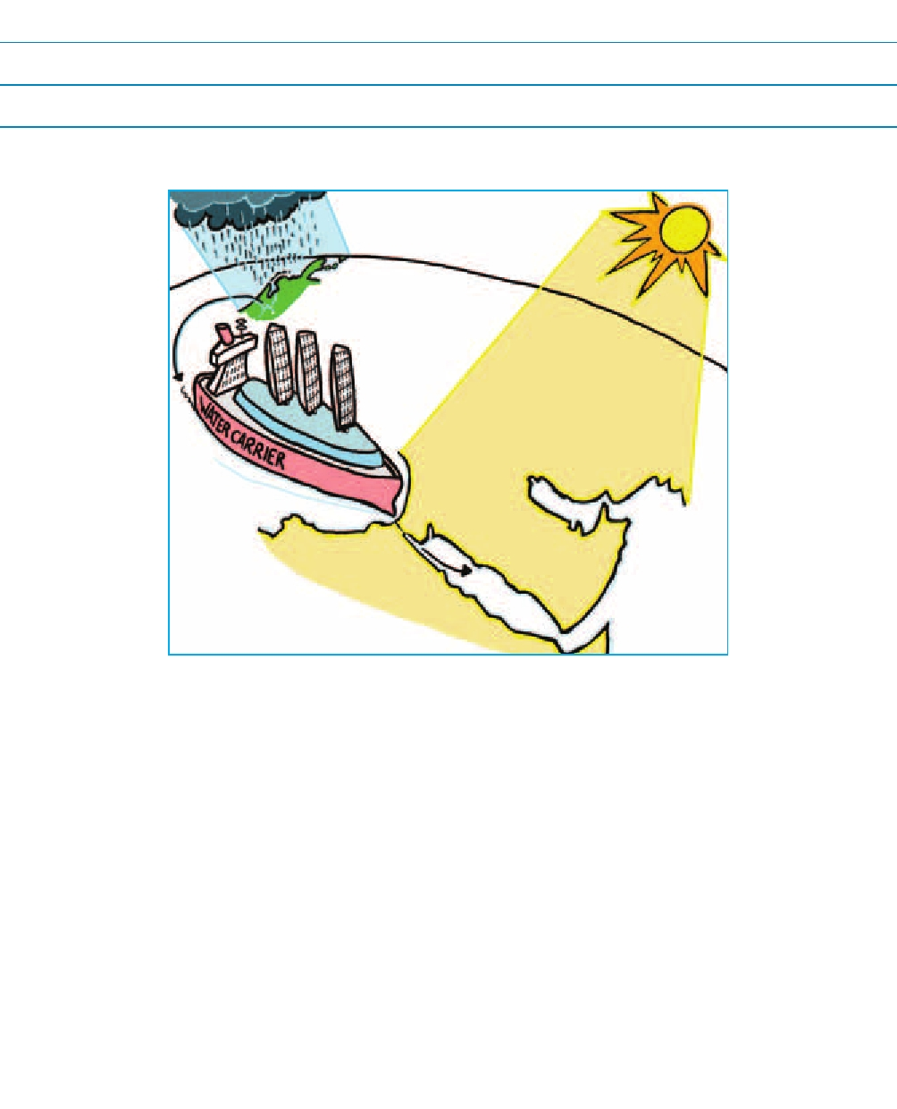
Reference
http://en.wikipedia.org/wiki/Water_export
Obeidi, A., Keith W. Hipel and D.M. Kilgour, 2002. Canadian bulk water exports:
Analyzing the sun belt conflict using the graph model for conflict resolution,
Knowledge, Technology & Policy, Volume 14, Number 4, 145-163, DOI:
10.1007/s12130-002-1020-2

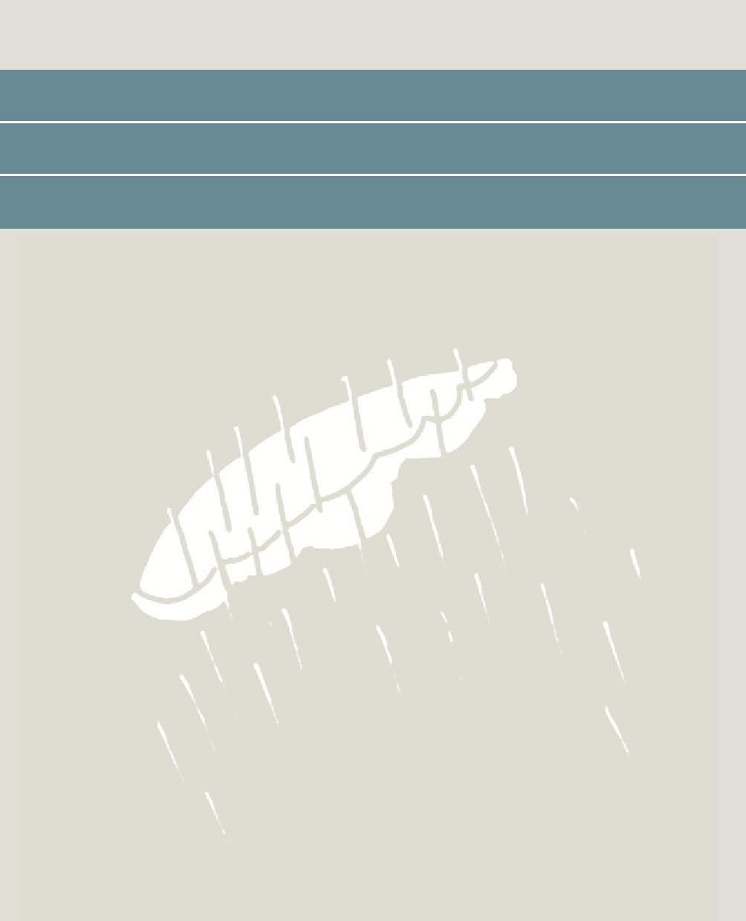

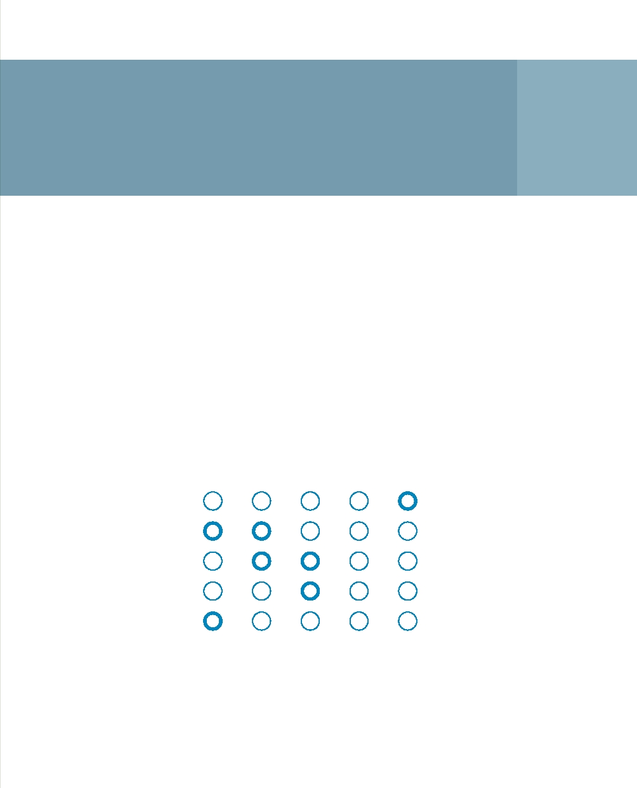
Strategic water storage
at depth 2

Water storage at depth or underground water storage is based on the principle of storing large volumes of fresh water for long periods of time in underground aquifers when there are surpluses so that this water can be used strategically during periods of scarcity.

Principle
During periods of surplus (winters and wet years) we take water from the surface or install facilities to collect rainwater. This water is then taken under pressure to a well that is connected to the groundwater in the deep subsurface. This creates a strategic store that we can draw on in times of scarcity (summers and/or dry years).

Strong Moderate Neutral Moderate Strong

Demand Availability

Hard Soft

Local International

Structural Emergency

Opposition Acceptance

Case studies
Underground water storage is already in widespread use at the international level, particularly for storing drinking water and in agriculture. For example, farmers in Gujarat (India) use the wells they have dug (which are several dozens of metres deep) to store in aquifers the rain that runs off their fields during the monsoon. In the Netherlands, underground storage is primarily used for drinking water supplies because the underground can be used to purify the water. Nevertheless, we are now infiltrating rainwater into the subsurface more often in built-up areas. This prevents problems with water at the street level and in the sewage system after heavy rain. An additional benefit is the extra recharging of groundwater, and the associated anti-drought effect. The Dutch policy relating to groundwater pumping is focused on maximising the conservation of groundwater as a strategic source of water. When groundwater abstraction exceeds a certain threshold, the water must be returned using deep infiltration. This has been done in, for example, the municipality of Haarlemmermeer, where pumped water is infiltrated in deep aquifers. However, underground water storage has not yet been used for the actual strategic management of water stocks.

Applicability in the Netherlands
Water storage at depth is an interesting alternative in hilly areas and/or areas where space is scarce because storing water above ground (at the ground level or in surface water systems) often conflicts with prevailing land use arrangements. The structure of the subsurface must permit this approach. Water storage at depth is promising but it is still not proven technology. A feasibility study is available for the Haarlemmermeer region with promising results (stating that the approach is technically possible and economically viable). There would also not appear to be any serious legal objections at this point. In other regions, such as the Veluwe area in the Netherlands, the picture with respect to feasibility could well be different and different technology may be needed.

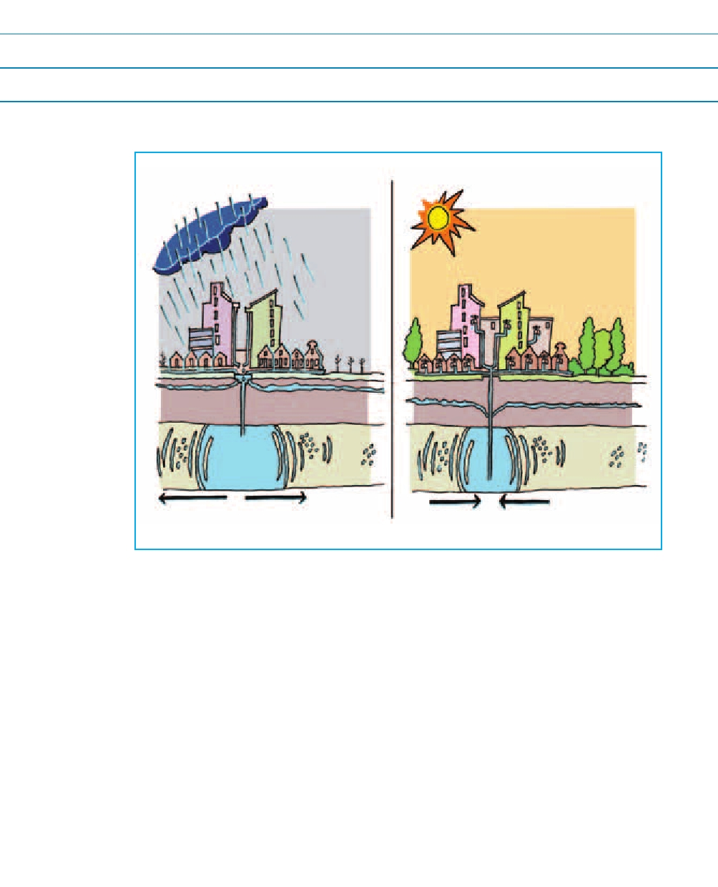
Reference
Houwing, E.T., Bremer, D.T., Kooiman, J.W., Brouwer, W., and A. Willemsen, 2005. Water storage at depth, Definition study of underground water storage to supplement surface water storage near Zwaansbroek (municipality of Haarlemmermeer), main report (in Dutch), Stichting Leven met Water



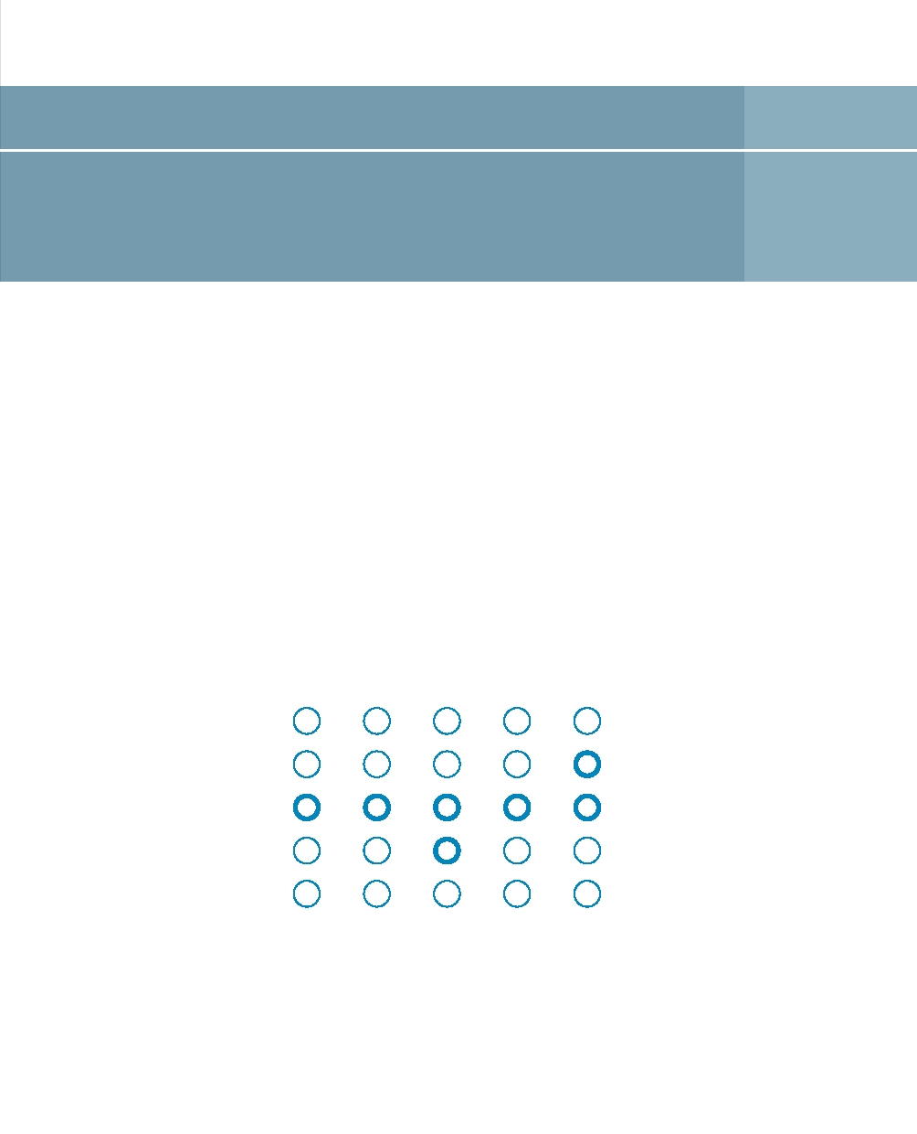
Serious gaming 3

Serious games are generally computer-based games that help to solve complex issues affecting society. They are ideal for addressing water management and drought issues.

Principle
Drought is a socially complex problem. Solutions require a great deal of creativity, not only in terms of the substance (the appropriate knowledge and technology) but also the process (cooperation between large numbers of stakeholders). The main challenge is the process. How can the substance and the process be properly orchestrated, and all the interests and options be considered? Even then, everybody needs to speak the same language. With serious games, stakeholders can practice precisely this process in a virtual environment.

Strong Moderate Neutral Moderate Strong

Demand Availability

Hard Soft

Local International

Structural Emergency

Opposition Acceptance

Case studies
Examples of serious games in water management include:
• Climate Quest, which was developed by UNESCO-IHE to raise awareness, primarily among younger people, of climate change and the impact it has on water management.
• CityOne, a training game developed by IBM for professionals to teach them how to respond to urban challenges like water management.
• The Water Allocator (Waterverdeler) is a serious game for members of the public with an interest in this field. Players of the game act as water managers and they take on responsibility for water management. As a water manager, you send river water flowing into our country to the areas where it is needed. You prevent salt intrusion and drought damage during the summer using dams and sluices in the main water system. The Water Allocator was developed under the auspices of WINN by Rijkswaterstaat Centre for Water Management, Deltares and Tygron Serious Gaming, with support from Leven met Water.

Applicability in the Netherlands
Serious gaming is booming, including in the field of water management. There are a range of games made for professionals and the general public, young and old. Serious games inform, raise awareness, train managers and make complex communications and decision-making processes, actors and interests understandable.

Benefits of serious gaming:
• Simulations cost much less than tests in reality.
• It is easy to try out different variants;
• You can experiment to your heart's content and learn without running risks;
• It is fun and it fits in with modern thinking and communications;
• It appeals to younger people.

Of course, there are drawbacks, such as 'players' who see the game as reality.

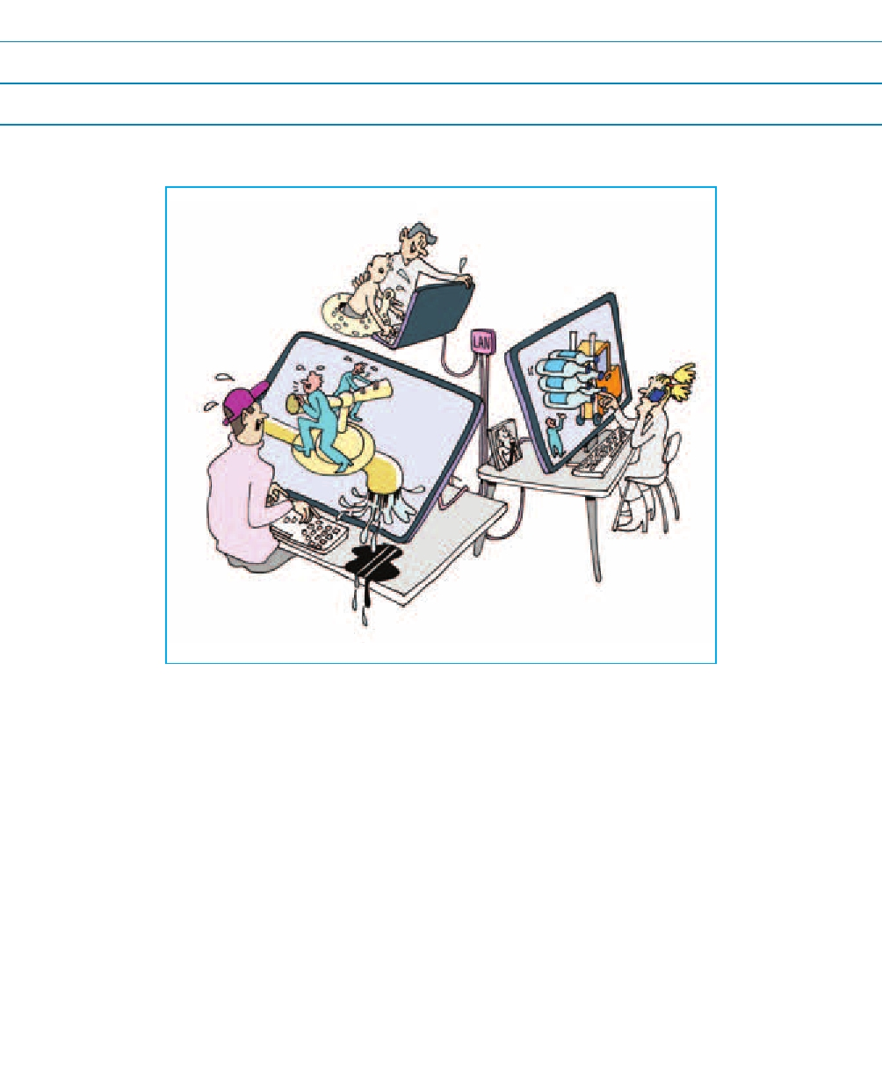
Reference
www.waterverdeler.nl

Rijkswaterstaat Waterdienst, 2010. Serious Gaming, Tool of the future!
Report on the WINN/LEF working conference on 11 February 2010, An initiative of the Rijkswaterstaat Centre for Water Management and the Verkeer en Waterstaat Inspectorate in collaboration with Deltares and the Rijkswaterstaat LEF Future Center. (in Dutch)

3 Serious gaming 25



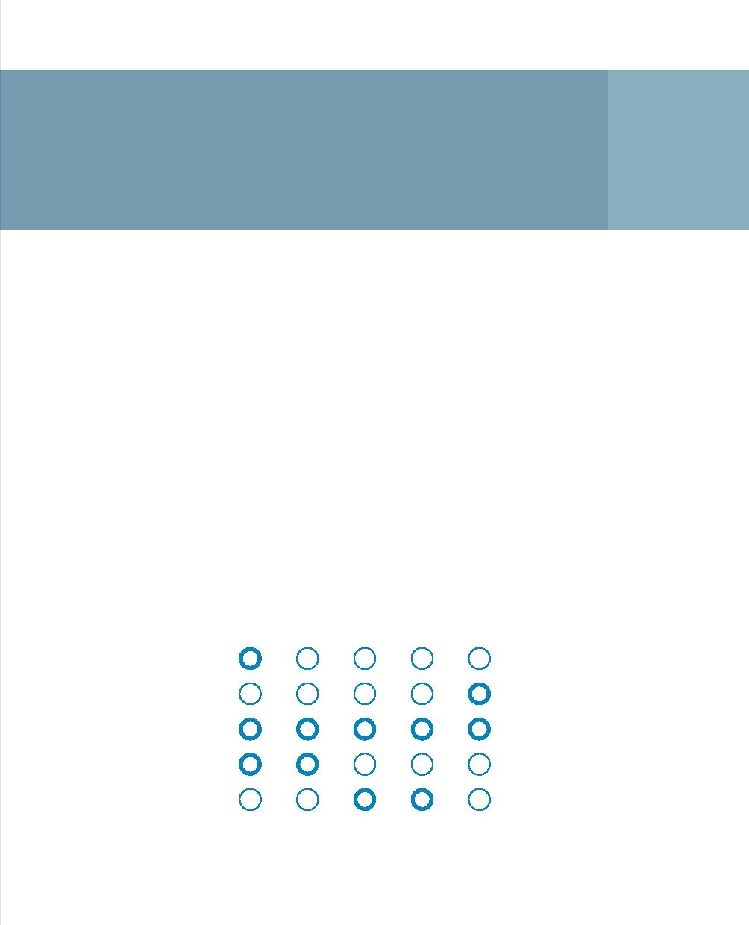
Eco-labelling
with water footprints 4

A water seal of approval - or eco-label - raises consumer awareness about the amount of water needed to produce a particular product or service and to get it to the consumer (in other words, the 'water footprint').

Principle
The world is becoming increasingly complex and that certainly applies to the production and transport of goods or services we buy. As consumers, our information about these processes is becoming increasingly limited and the

The Water Footprint Network calculates water footprints for specific products, people's day-to-day lives, businesses and countries. For example, one kilogramme of beef 'costs' approximately 10,000 litres of water, while a kilogramme of grain costs 1000 litres. A litre of beer from South Africa has a water footprint of 150 litres, whereas a brewer from the Czech Republic can manage with just 45 litres.

Strong Moderate Neutral Moderate Strong

Demand Availability

Hard Soft

Local International

Structural Emergency

Opposition Acceptance

Eco-labels provide consumers with straightforward information about the water footprint of a product or service so that they can make informed choices. By selecting products with smaller footprints, consumers can help to reduce water consumption.

Case studies
Labels are used successfully in many fields, both nationally and internationally. A few known examples in the Netherlands include:
• For consumer safety: Ik kies bewust, KEMA-keurmerk;
• For ethical companies and services: Fair trade, child labour free;
• Environmentally friendly FSC-hout keurmerk, EKO keurmerk, EU Eco-label.

Applicability in the Netherlands
A wide range of water labels could be introduced in the Netherlands. It is important for people to realise that it is not only consumer products in supermarkets that can benefit from eco-labels, but also completely different types of services and products. For example, industries that extract water from groundwater could acquire a label if they take steps to save water during the production of their products. The water footprint of certain types of land use could also be assessed and labelled. For example, if we flush our water systems with water to prevent salt intrusion, that decision has a specific water footprint.

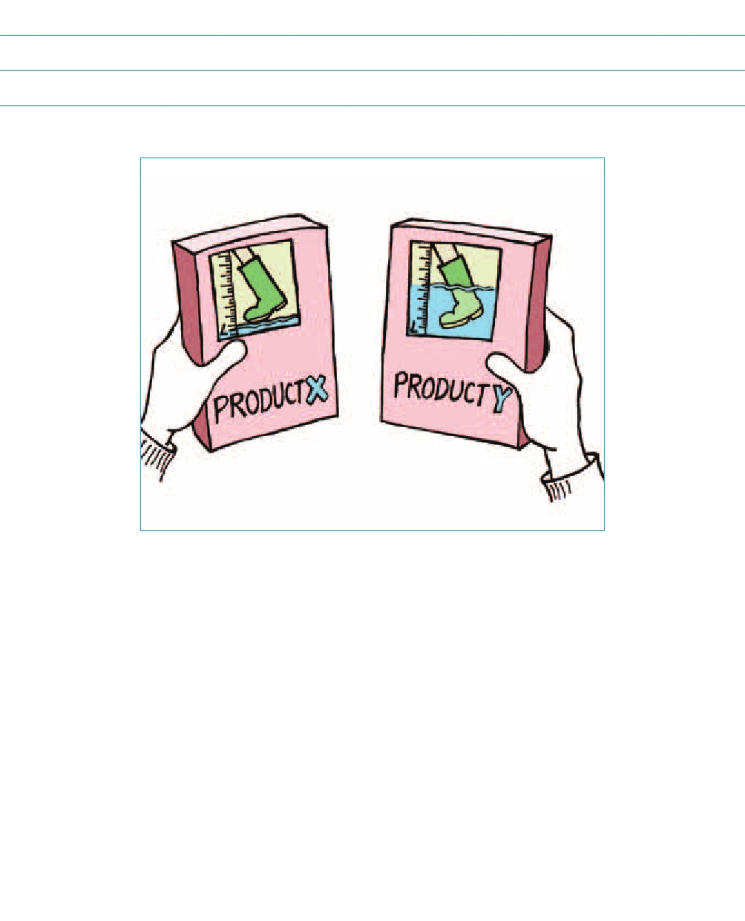
Reference
www.waterfootprint.org

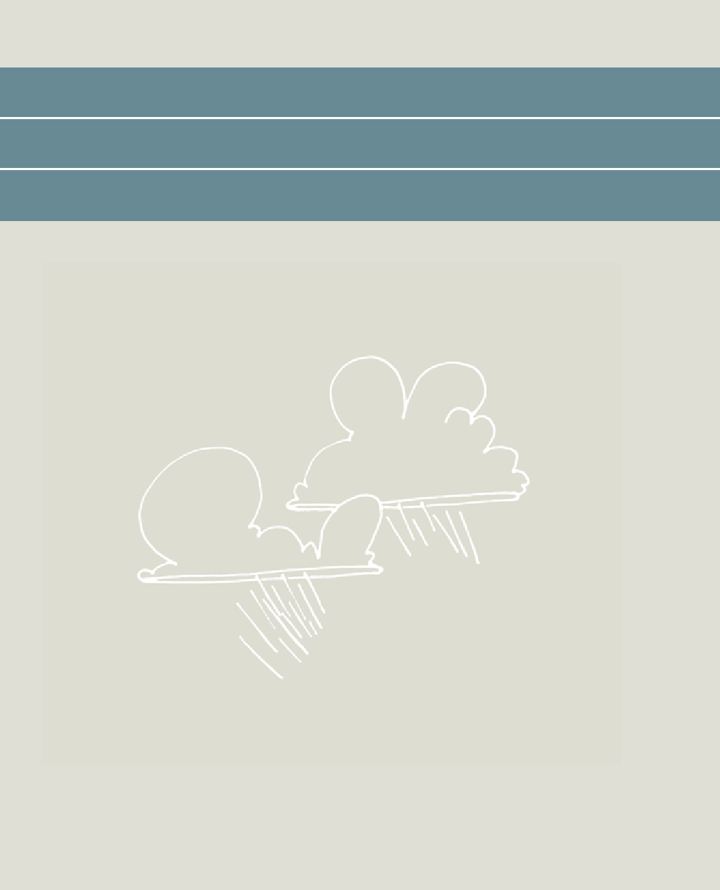

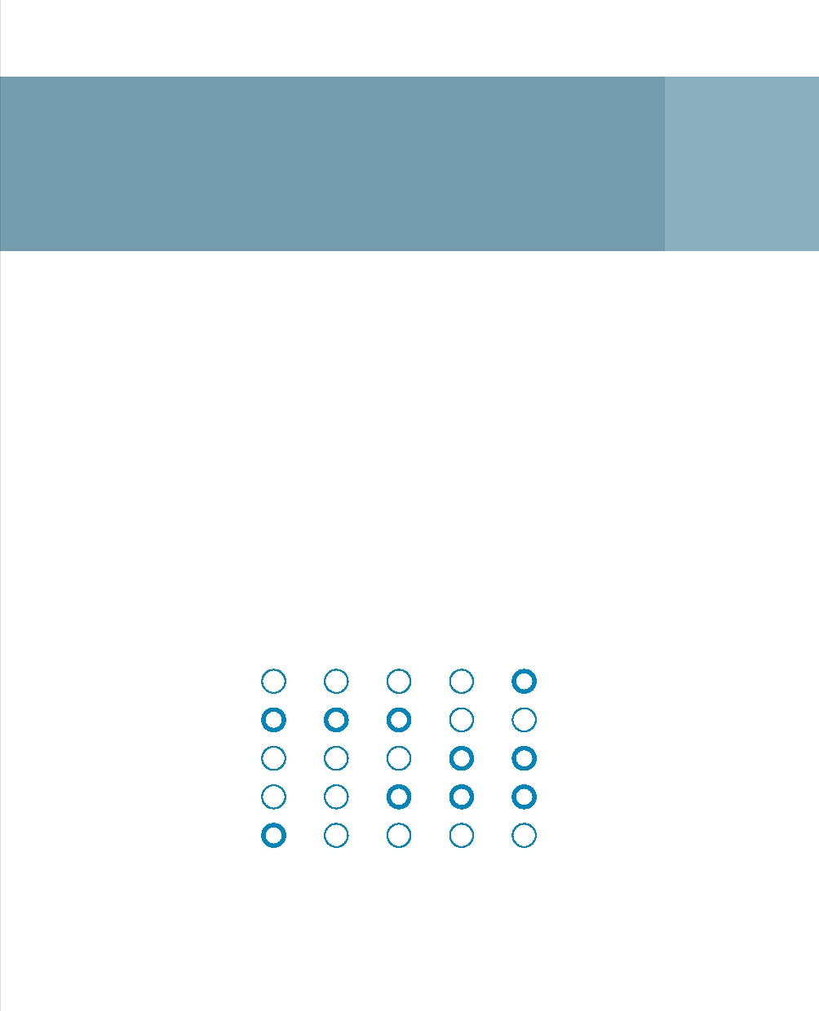
Cross-boundary approach
to drought and water scarcity 5

The West European Climate Corridor (WECC) is a proposal for cross-border cooperation to tackle problems with drought and water scarcity at the level of the Rhine catchment.

Principle
The West European Climate Corridor (WECC) is based on principles that typify the current approach to water management. It assumes that solutions to drought and water scarcity (as experienced in the Netherlands) are located in the Rhine catchment as a whole. Even as far up the river as Switzerland. Solutions can be found in the river itself, in lakes, groundwater and also in the subsurface. After all, all these systems are linked. They are part of a single entity. In broad terms, the aim is to slow down discharge rates by retaining the water longer at source and to establish a more natural approach to regulating discharge rates by allowing the landscape to serve more as a buffer.

Strong Moderate Neutral Moderate Strong

Demand Availability

Hard Soft

Local International

Structural Emergency

Opposition Acceptance

The WECC is based on the idea of the multi-functionality of possible measures that target flood risk, drought and water scarcity, CO2 mitigation and nature conservation at the same time. It aims to link up with other initiatives in place, and with policy in the field of water, nature and spatial planning.

Case studies
The study is exploring ideas such as the use of reservoirs in the Alps (1, 2:
the numbers refer to the illustration on the following page), storage in Lake Constance, storage in the capillaries of the Rhine (3) and in the groundwater system of large areas in Germany as possible interventions. It does so in conjunction with Dutch ideas like Room for the River (4) and storage in the IJsselmeer (5).

Applicability in the Netherlands
Tackling problems with drought and water scarcity require not just a Dutch approach but rather, and indeed, international collaboration. Drought and water scarcity are, after all, a 'common issue' in the Rhine catchment (they also have an effect on countries upstream of us) and a cross-boundary challenge (for international water management).

The West-European Climate Corridor is a good example of a Dutch stakeholder in water management (in this case the provincial authority of Gelderland) that is looking for solutions - pro-actively and in an international context - for drought and problems with low water levels. Of course, there are other initiatives of this kind. For example, the European Union has, by introducing the Water Framework Directive, encouraged the quest for solutions at the catchment level by asking for 'Drought Management Plans'. Combining initiatives and alliances between the various Dutch water management authorities and their foreign counterparts is an obvious step here.

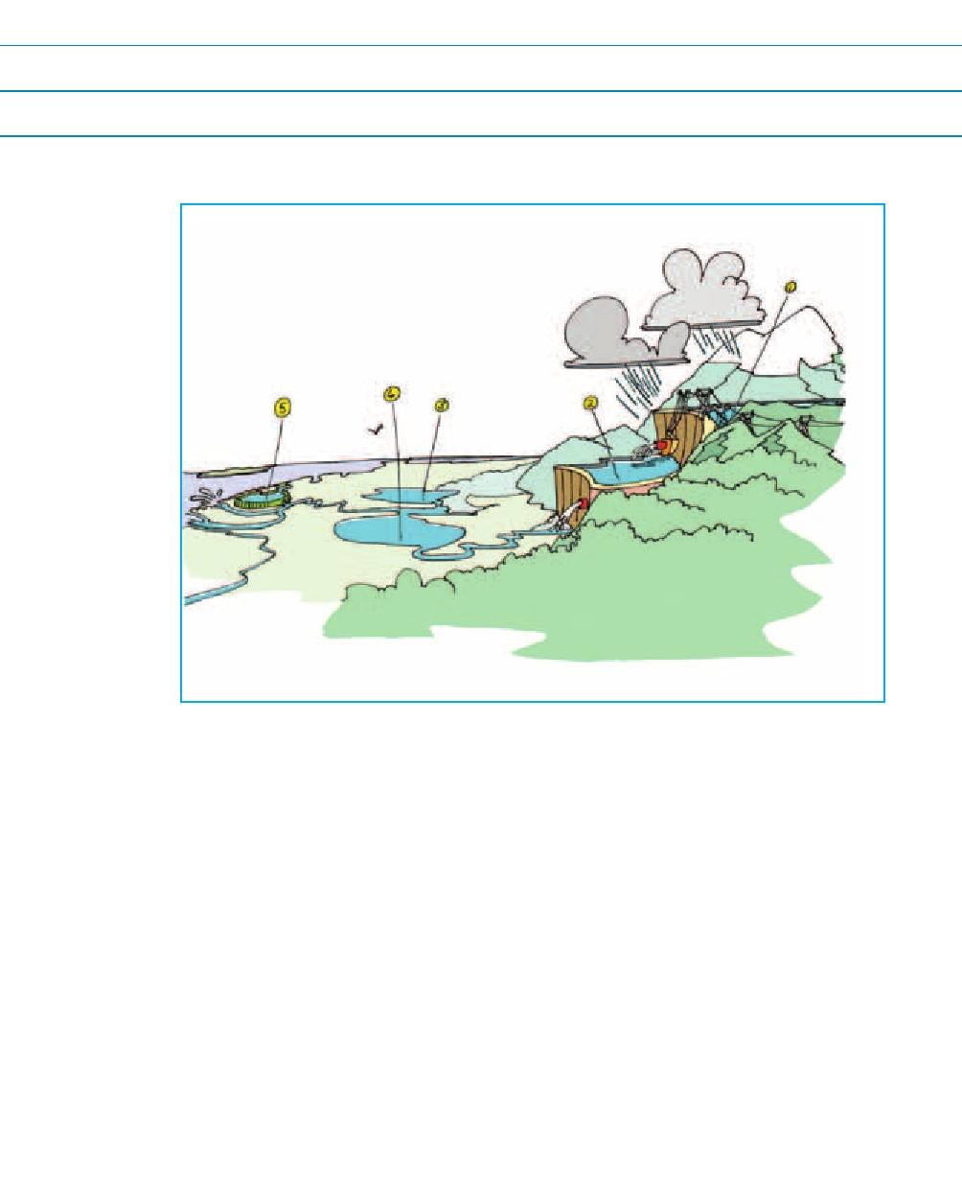
Reference
Royal Haskoning, 2010. West European Climate Corridor, Discussion of water-related aspects, commissioned by the Gelderland provincial authority (in Dutch)

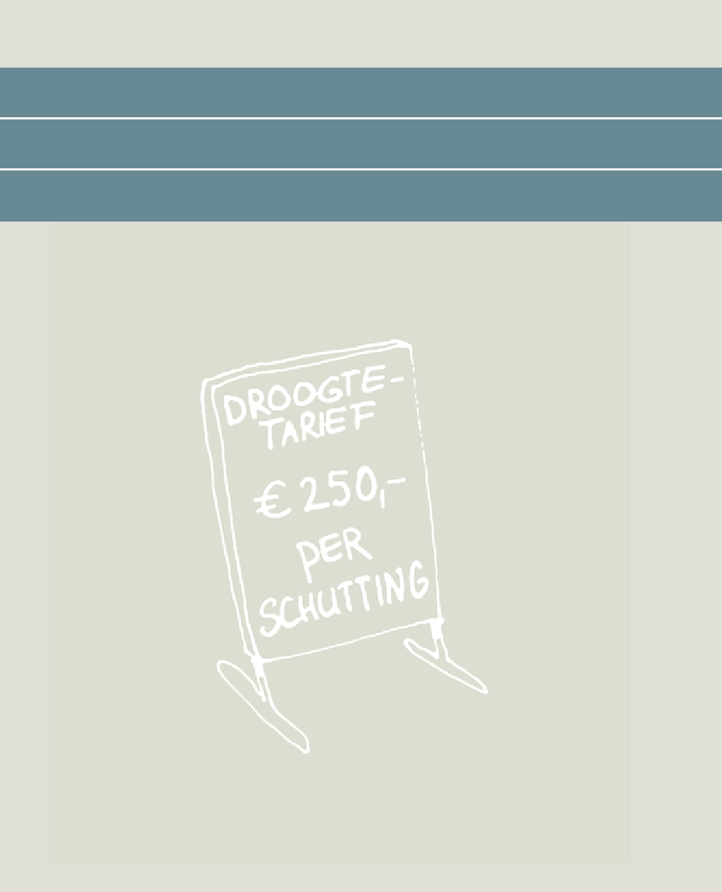

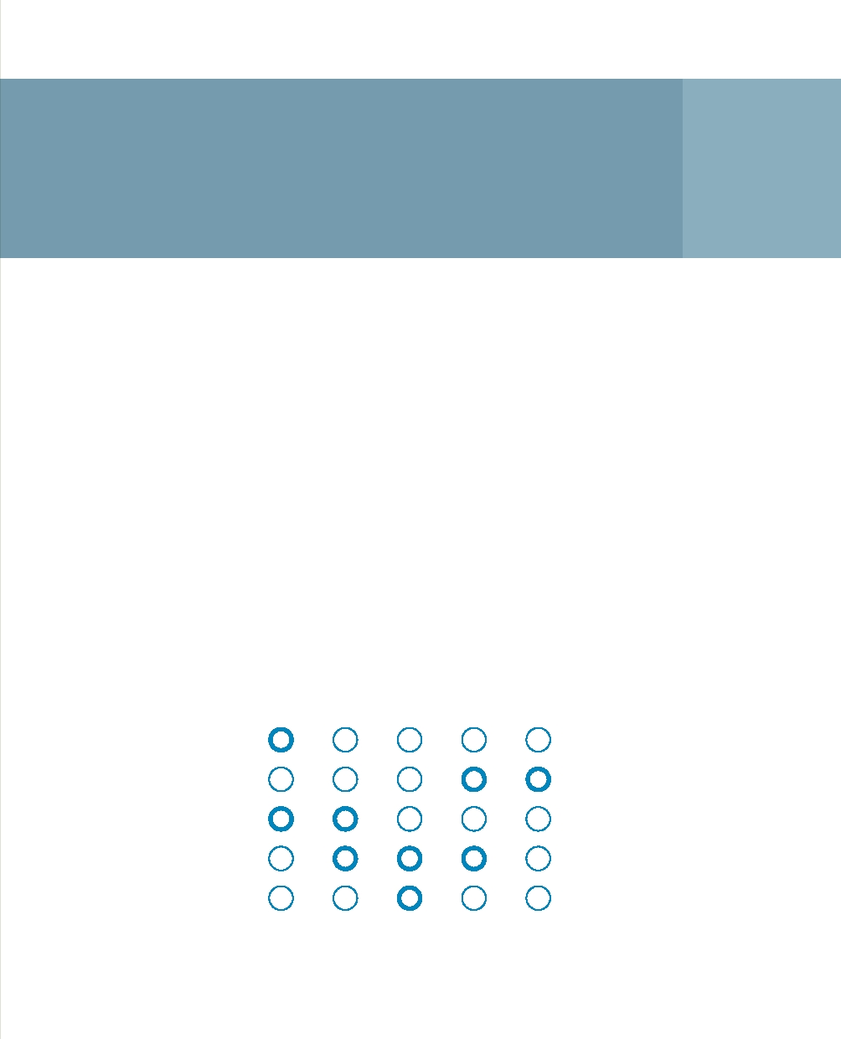
Drought-dependent
water charges 6

The idea of drought-dependent water charges involves allowing the amount people pay for water to vary according to drought levels in particular locations and at particular times. The economic incentive raises awareness among water consumers of the scarcity of water and encourages them to use water more carefully.

Principle
In many countries, people do not pay for the water they use, or they pay only some of the costs involved in supplying consumers with water. The reason is that most societies believe that everybody should have clean water for consumption and domestic use. However, if water costs nothing, people do not use it as carefully and the available water is not allocated in the best economical way.

This principle is based on the idea that we can see water as an economic asset and that putting a price on water consumption and other forms of water use results in more economical and more effective use.

Strong Moderate Neutral Moderate Strong

Demand Availability

Hard Soft

Local International

Structural Emergency

Opposition Acceptance

6 Drought-dependent water charges 35

Case studies
Political sensitivities mean that only a few countries are prepared to use water prices as an economic incentive to manage water demand. A worldwide study^{5,6} of water rates in 2008 found that charges have only increased to a very limited extent in recent years. The same study showed that water charges are generally not dependent upon the level of water scarcity. Consumers in parts of the USA where water is scarce, and in the Middle East, pay much less for their water than users in North-West Europe. There are only a few countries where agricultural irrigation involves a fee, even though farming is actually a major consumer of water.

Applicability in the Netherlands
Drought-dependent water charges could be used in the Netherlands for domestic water consumption. Drought-dependent rates raise public awareness of scarcity and encourage people to use water more carefully. This system can be particularly effective when water consumption is monitored at regular intervals so that consumers become aware of how they use their water. Households can see whether there is a drought on public Drought Early Warning Systems (see Rainfall Radar for drought).

This system of drought-dependent water charges may be interesting for water management authorities if we set prices not only for water consumption but also for water services, and charge consumers. An option may be to charge for the intake of cooling water during droughts, and for going through locks where water is lost. The question that immediately arises is who the direct clients are for these types of water service. After all, it is the user who is expected to pay.

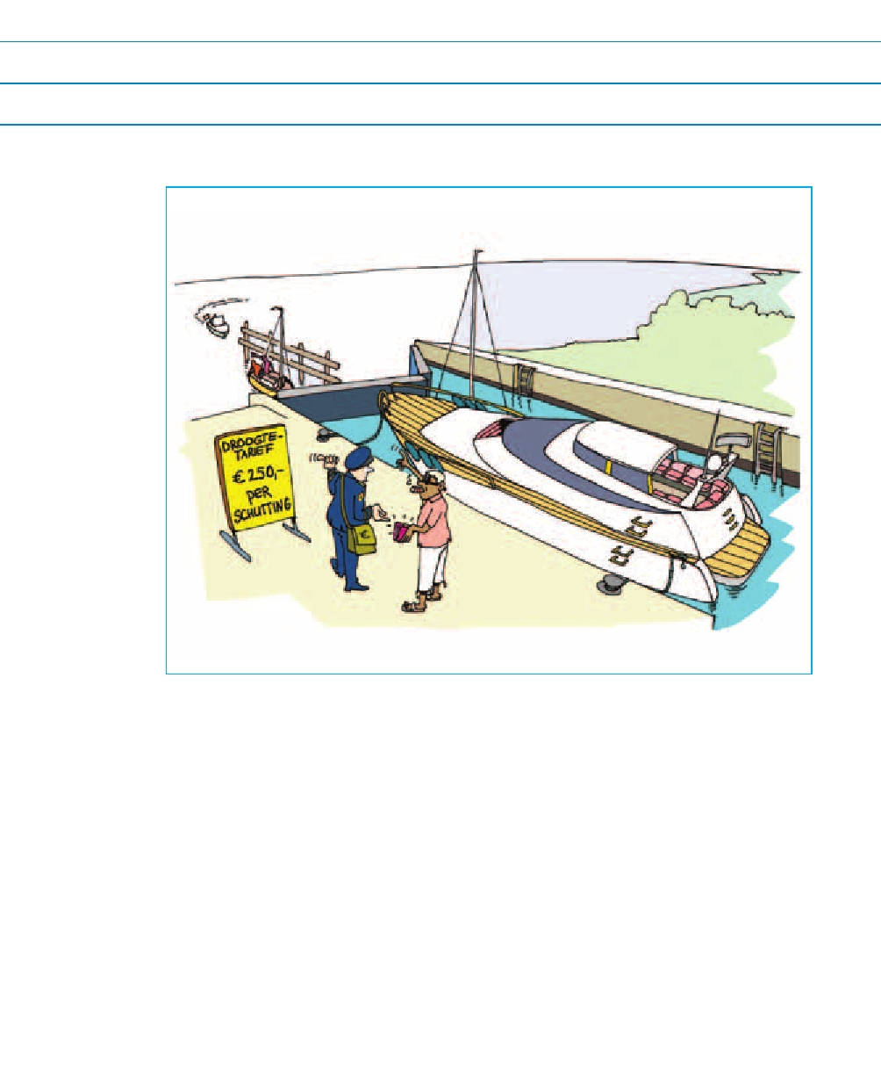
Reference
Anonymous, 2010. Water metering and Billing, Waterbiz, Vol. 2 (2), pp. 16-17

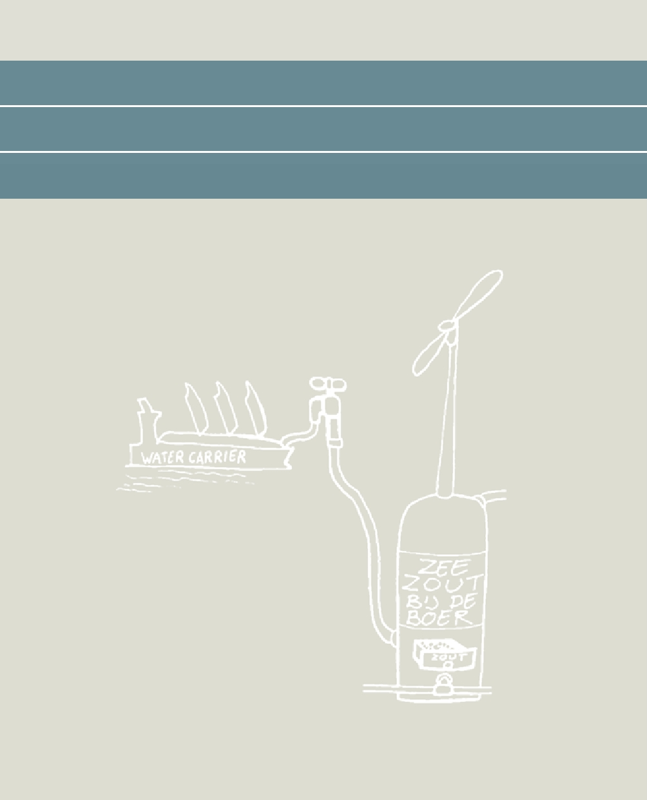

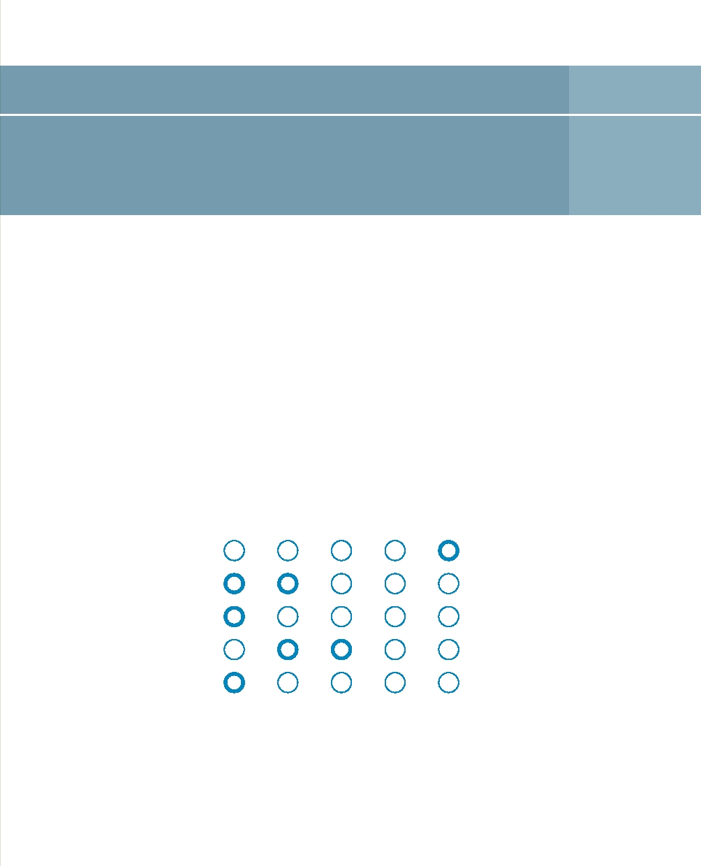
Innovative desalination 7

Innovative desalination techniques make more water available in vulnerable areas. This is a cost-effective and sustainable approach.

Principle
In recent years, desalination technology has developed rapidly and it is being used more and more widely. The basic principle underlying this technology is that you can make fresh water from salt water by distilling it or by passing it through a membrane filter that lets the water through but stops the salt. However, extracting fresh water from salt water requires a lot of energy. And the residue left after desalination, the 'brine' with extremely high salt levels, can be harmful for the environment if it is not disposed of intelligently.

Strong Moderate Neutral Moderate Strong

Demand Availability

Hard Soft

Local International

Structural Emergency

Opposition Acceptance

Innovations in desalination therefore focus on:
• Reducing the energy needed for the various desalination processes;
• Using smart energy sources other than fossil fuels, such as wind and solar energy and geothermal, and the smart use of residual heat or waste heat from other industrial processes (this is known as co-generation);
• Smart positioning to mitigate negative environmental effects.

Case studies
Developments in membrane technology of the kind introduced by TNO and NORIT have resulted in ultra-filtration and nano-filtration with low energy consumption. Technologies like Aquastill and Memstill combine distillation processes with membrane technology and rely in part on waste heat as an energy source. The Dutyion Root Hydration System is a smart agricultural irrigation system that consists of a network of small underground pipes. This system uses differences in moisture levels to pass the incoming salt water through the pipe walls into the soil. The pipe walls filter out the salt in the water. The Water Pyramid consists of a pyramid-shaped tent that uses solar energy to distil salt water (and it is therefore particularly suitable for the tropics and subtropics).

Applicability in the Netherlands
The Dutch Rainmaker uses wind energy to guide the desalination process. The wind turbine that has been developed can desalinate approximately 60 m³ a day. This can be done locally anywhere where there is wind and salt water, without taking up a lot of space or incurring high energy costs. Wind is in plentiful supply in the Netherlands. It is possible that Dutch farmers in areas with brackish and salt groundwater can use it to fill a water store (see page 24). In that case, it will be possible to limit the amount of fresh water brought in from other areas.

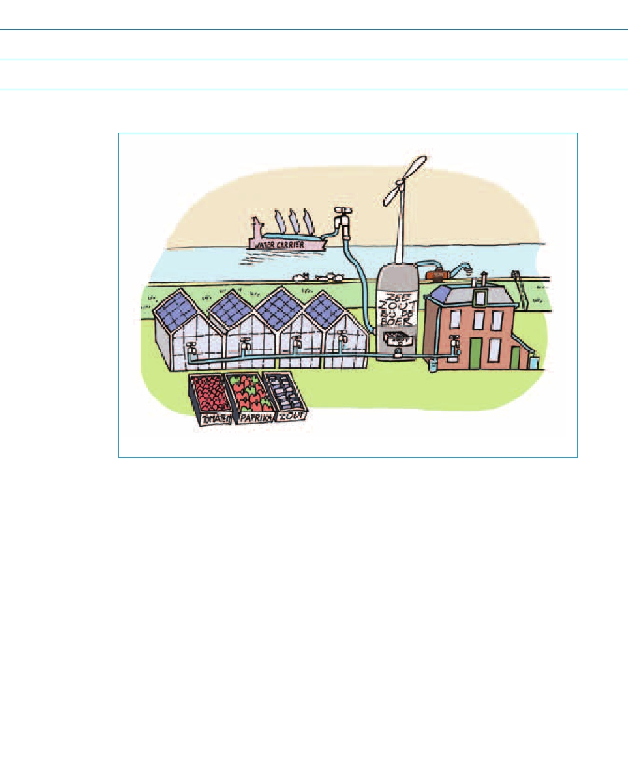
Reference
www.dutchrainmaker.nl

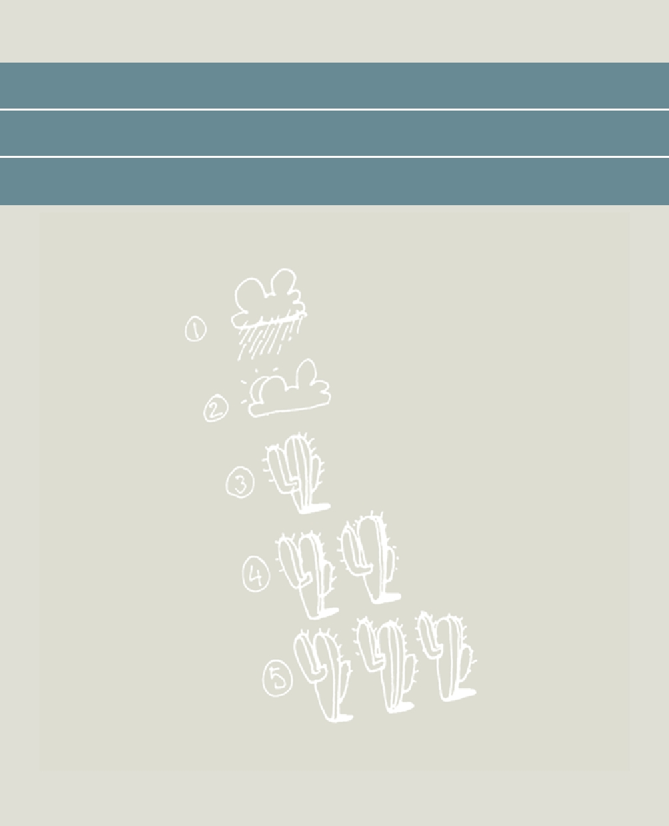

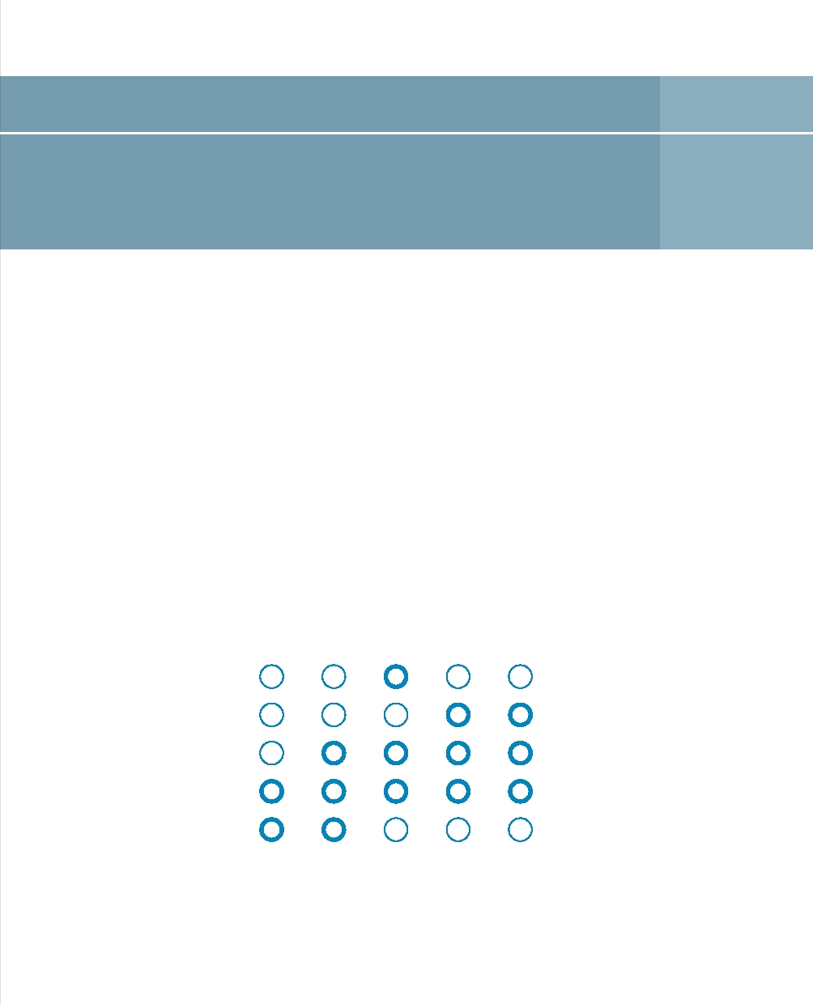
Rainfall radar for drought 8

The Rainfall Radar For Drought is a computer system that draws on meteorological and hydrological measurements to provide information about current drought and water scarcity levels. It predicts developments and communicates them effectively to stakeholders.

Principle
The Rainfall Radar For Drought combines data from a range of monitoring networks with the forecasting capacity of computer models used in meteorology and hydrology. Drought forecasts generally start with weather forecasts from meteorological institutions. These values are used as input in a range of hydrological models to produce forecasts for all sorts of water variables such as water levels, water temperatures, flow rates in the river system and soil moisture levels in upper soil levels, and water levels in the deeper subsurface.

Strong Moderate Neutral Moderate Strong

Demand Availability

Hard Soft

Local International

Structural Emergency

Opposition Acceptance

Linked models that subsequently simulate plant growth stress, salt intrusion into rivers and groundwater, forest fire risk, ecosystem health, eutrophication and food availability complete the drought forecast. The value of a forecast of this kind increases if we communicate continuously, quickly and convincingly with water management authorities, farmers, the shipping sector and nature management. Good drought indicators and accessible real-time ICT systems can help in this respect.

Case studies
The development and application of DEWS systems (drought early warning systems) is an extremely topical issue at the international level. Meteorological institutions such as the Dutch KNMI, UN organisations like the FAO, research institutes, water management authorities and foreign development organisations are all involved in the development of systems of this kind.

Applicability in the Netherlands
In periods of drought and water scarcity, the National Coordination Committee for Water Allocation (LCW) advises on the best way of allocating available water to the various users. This decision is supported by information relating to both current and future water availability. The Netherlands Hydrological Instrument (NHI) that generates this information is a collection of models that is used on a day-to-day basis and that is made up of a distribution model with national coverage and a surface water model. These models are linked to another model - again with national coverage - for the saturated and unsaturated zones. The NHI receives meteorological input consisting of measured and predicted precipitation and evaporation. The instrument also provides a picture of current and predicted water demand in a range of sectors. The entire system has been operationalised in an operational forecast system for managing data and models in a real-time environment. Rijkswaterstaat is one of the Dutch parties developing and applying the NHI Drought Early Warning System.

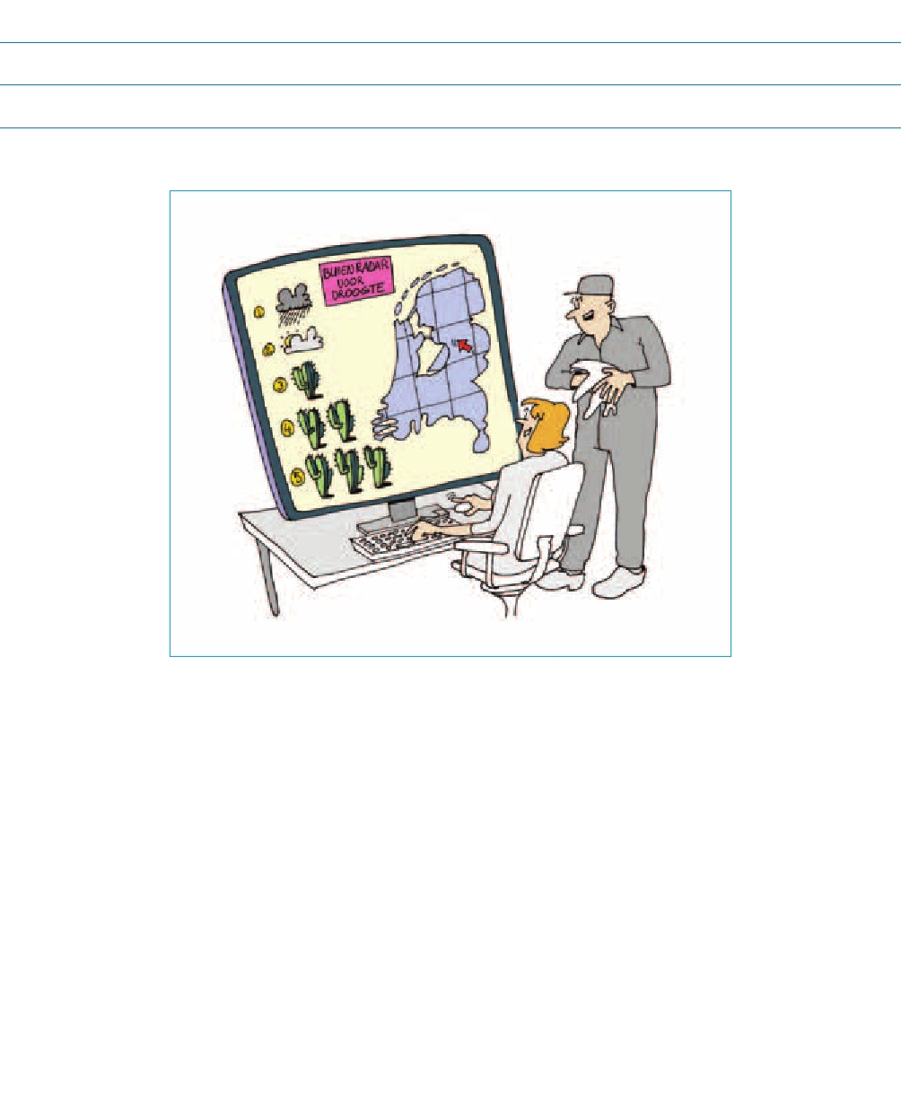
Reference
www.nhi.nu

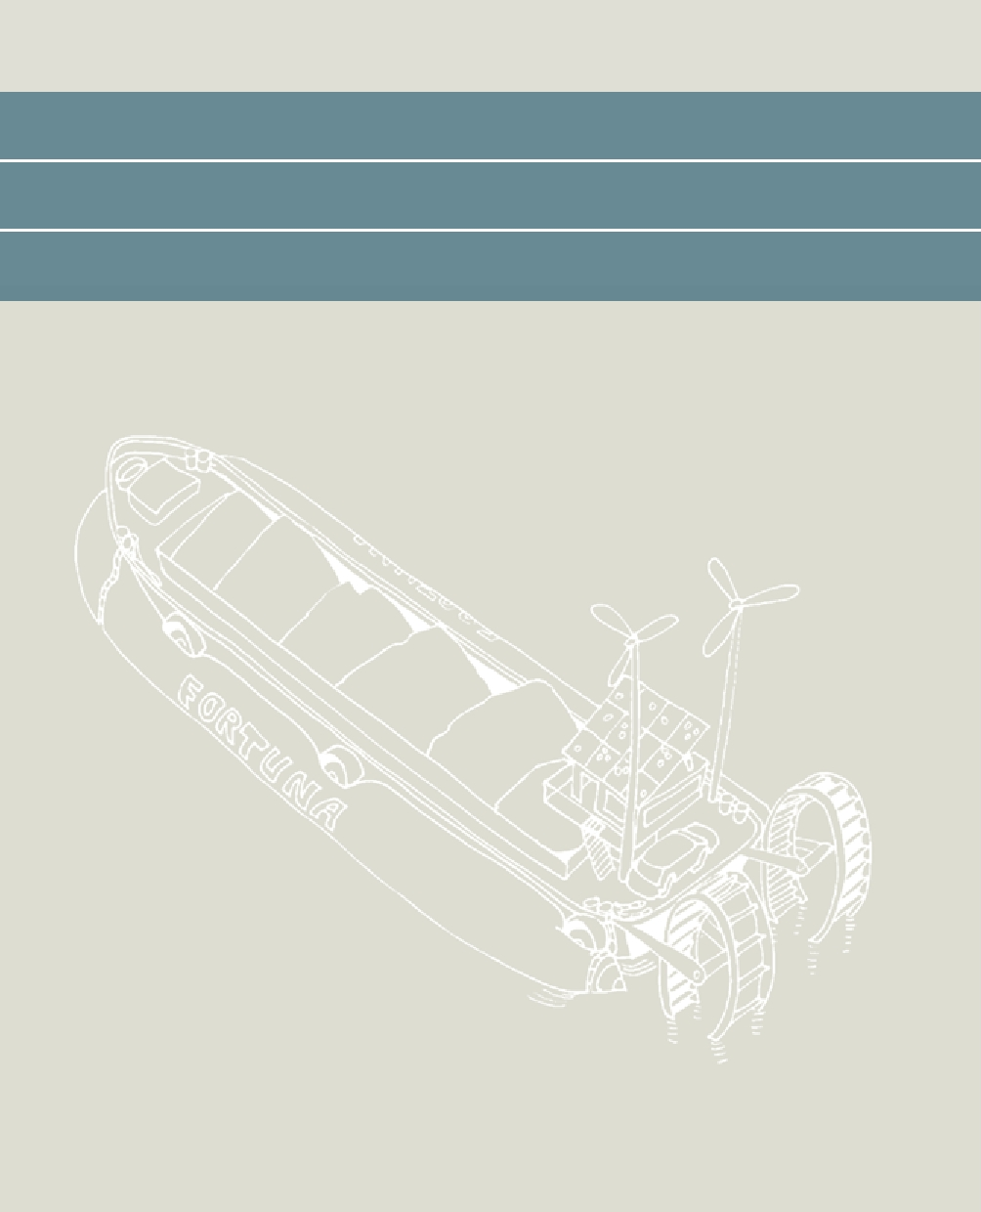

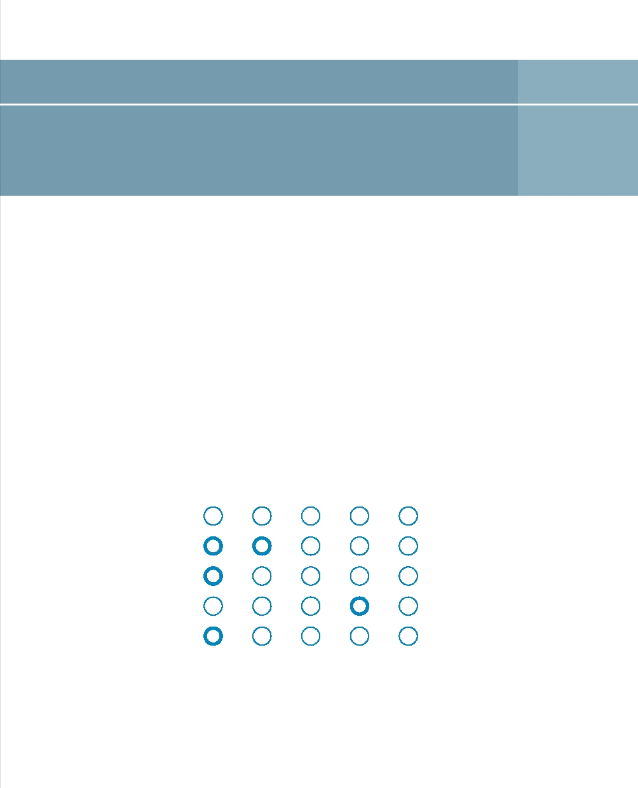
Drought ship 9

Drought ship stands for a system of possible solutions available to the inland shipping sector for tackling low water. It assumes that the sector can cope without outside help.

Principle
Studies have indicated that, if the dry climate scenario becomes a reality, extremely low water levels of the kind seen in 2003 will be an annual occurrence by about 2050. In combination with the trend towards ever-larger vessels with larger draughts, this fact means that inland shipping is more vulnerable to low water. The sector is aware of this and has taken steps to identify solutions for meeting this challenge. The same applies to high water levels, which may constitute an even more daunting transportation challenge.

Strong Moderate Neutral Moderate Strong

Demand Availability

Hard Soft

Local International

Structural Emergency

Opposition Acceptance

Case studies
The inland shipping sector is considering a number of possible solutions for coping with low water levels. Proposed infrastructure options include raising back-pumping capacity at locks to limit lock losses and so that the frequency with which the locks are used need not be cut back when water levels are low. Logistical options include sailing for longer periods of time when water levels are low and establishing safeguards to ensure that there is an adequate reserve of ships and crew. The option of carrying half cargoes during periods of low water need not necessarily be bad for the ship operators. The associated rise in demand for vessels pushes up the price of transportation. Developments in ITC, which allow information to be available about low water, ship locations, harbour capacity and locks at any given moment, are opening up the way to smart logistical planning. DSM in Limburg is already operating a system of its kind to optimise their transport on the Meuse. It goes without saying that a partial solution to the challenge of low water levels is to design vessels with shallow draughts that can also sail faster. The use of lighter materials, two small propellers rather than a single large one, and other types of propulsion systems that cause less turbulence are just some examples of how the inland shipping sector is making improvements to its own production resources.

Applicability in the Netherlands
Public water management authorities can only do so much during droughts in terms of maintaining the navigability of waterways. Water managers must combine this important message with incentives to encourage the 'self-sufficiency' of private sectors such as inland shipping, or agriculture. Not only by top-down management but also, and above all, by looking for solutions as a partner who works on an equal footing with those sectors.

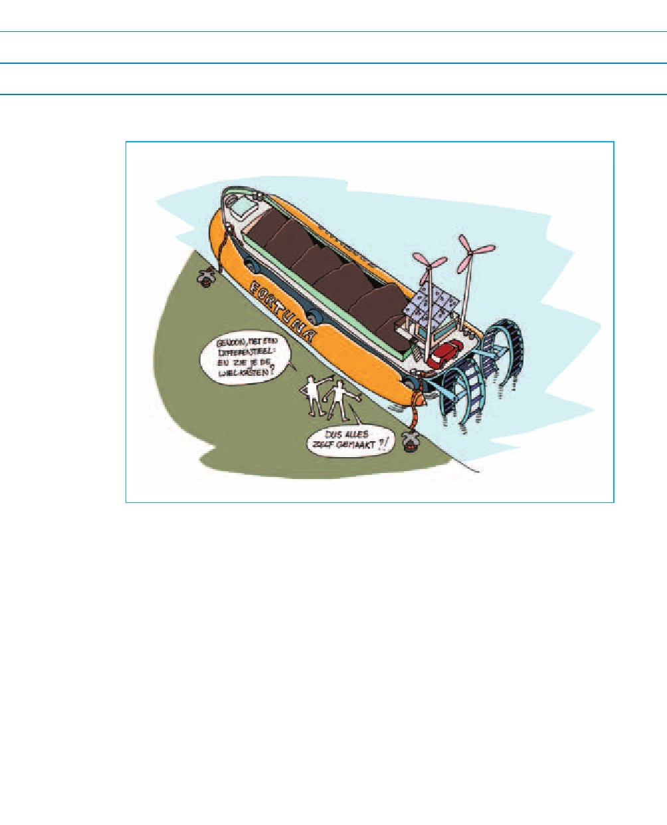
Reference
Bosschieter, C.G., 2005. Climate change and inland shipping. Impacts on inland shipping of more extremely low (and high) water levels in the Rhine, Master's thesis for the Faculty of Civil Engineering and Geosciences, Delft (in Dutch)

9 Drought ship 49

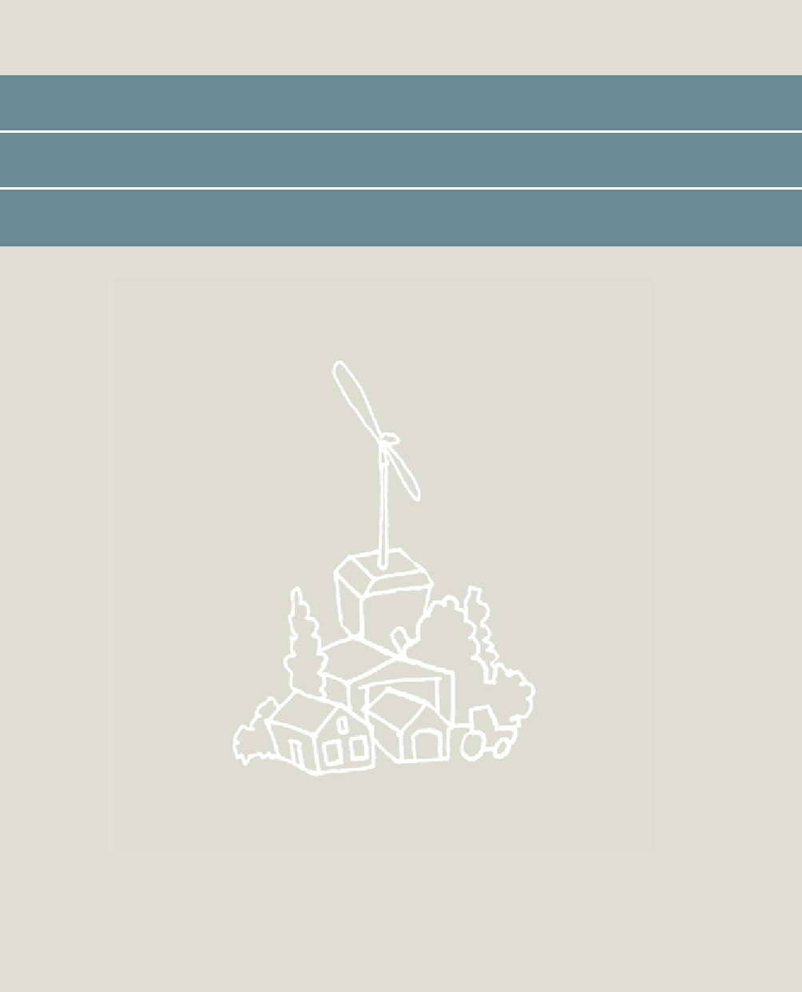

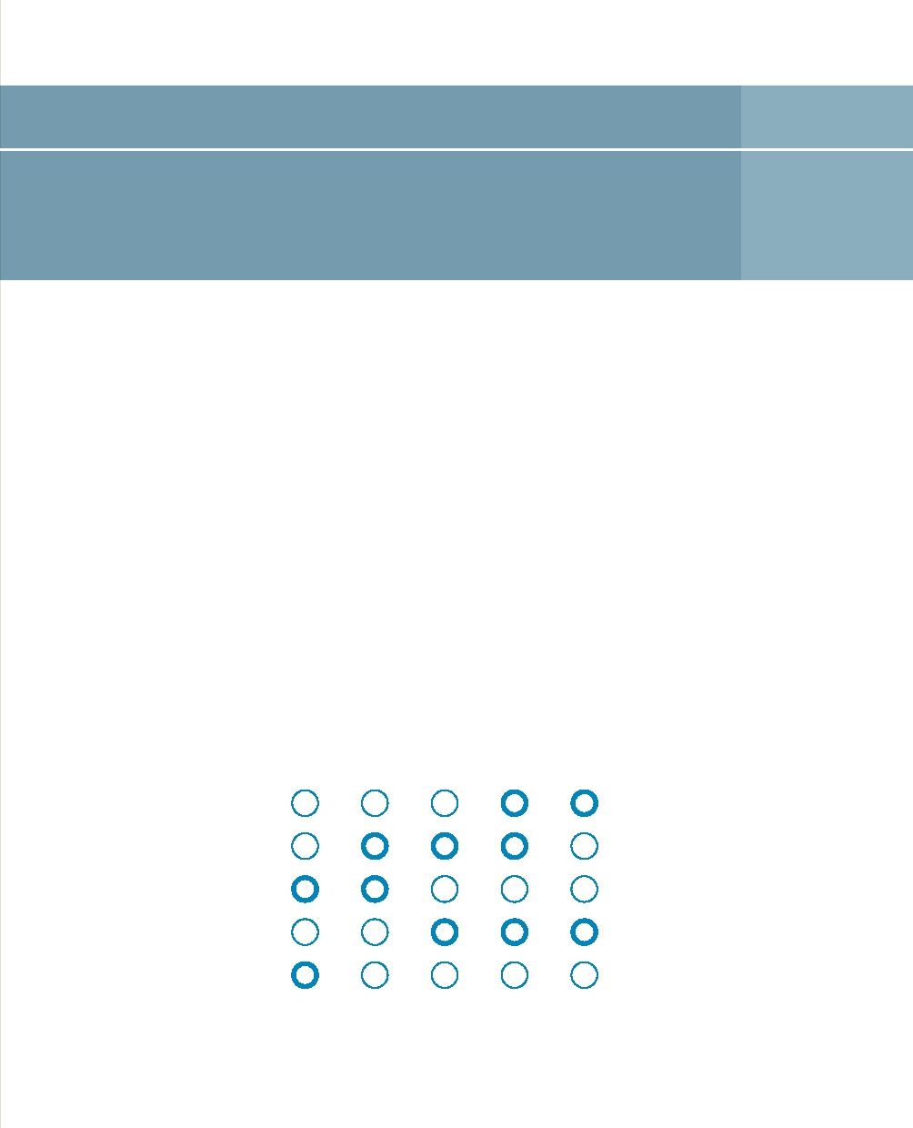
Water husbandry 10

In Water Husbandry, landowners, government authorities and local inhabitants work together on using water 'down to the last drop'. The Water Husbandry system is used to store, retain, use, treat and supply water so that bringing in water from elsewhere becomes unnecessary.

Principle
Water Husbandry organises and manages water storage areas in such a way that they have the potential to develop into an economically appealing activity for farmers and other stakeholders. An ambitious vision of the future could be as follows: in a pilot area measuring 500 hectares, farmers, other businesses, landowners, the municipality, the water management authorities and local inhabitants establish a cooperative, a 'Water Husbandry'. It stores water for the area after rainy periods and retains the excess rain so that water supplies are optimised in the dry growing season for commercial crops.

Strong Moderate Neutral Moderate Strong

Demand Availability

Hard Soft

Local International

Structural Emergency

Opposition Acceptance

Case studies
One of the pilot studies is being conducted on the island of Walcheren. During the springs and summers of recent years, this period had the most severe rain shortfall in the Netherlands. Sources of fresh water are not readily available and so drought damage resulted. If adequate supplies of fresh water are in place, farmers confidently expect to boost crop yields from current crops by 20% in this area. Landowners and owners of nature areas have also indicated that shortages of fresh water cause problems for them. All the local parties get together with government authorities to explore ways of managing fresh water without causing problems with water during wet periods. This involves looking at options such as retaining fresh water from the dune areas, storing fresh water in holdings and estates, structuring nature areas so they act as retention areas, and retaining water in the subsurface better.

Applicability in the Netherlands
The expectation is that extremely wet periods will alternate in the future with longer periods of drought and water scarcity. As a result, there is an increased risk of drought damage and/or salt damage in some areas. Increasing water demand during droughts puts more pressure on the main water system. By making local regions more self-sufficient, we can save on the costs of water transport.

This is already an issue in a number of areas. For example, Tholen's fresh water supplies depend on the Volkerak-Zoom Lake, where the water is still fresh. If that lake becomes salt, and Tholen can organise its own fresh water supplies, there will be no need for expensive investments to supply fresh water to Tholen using the main water system.

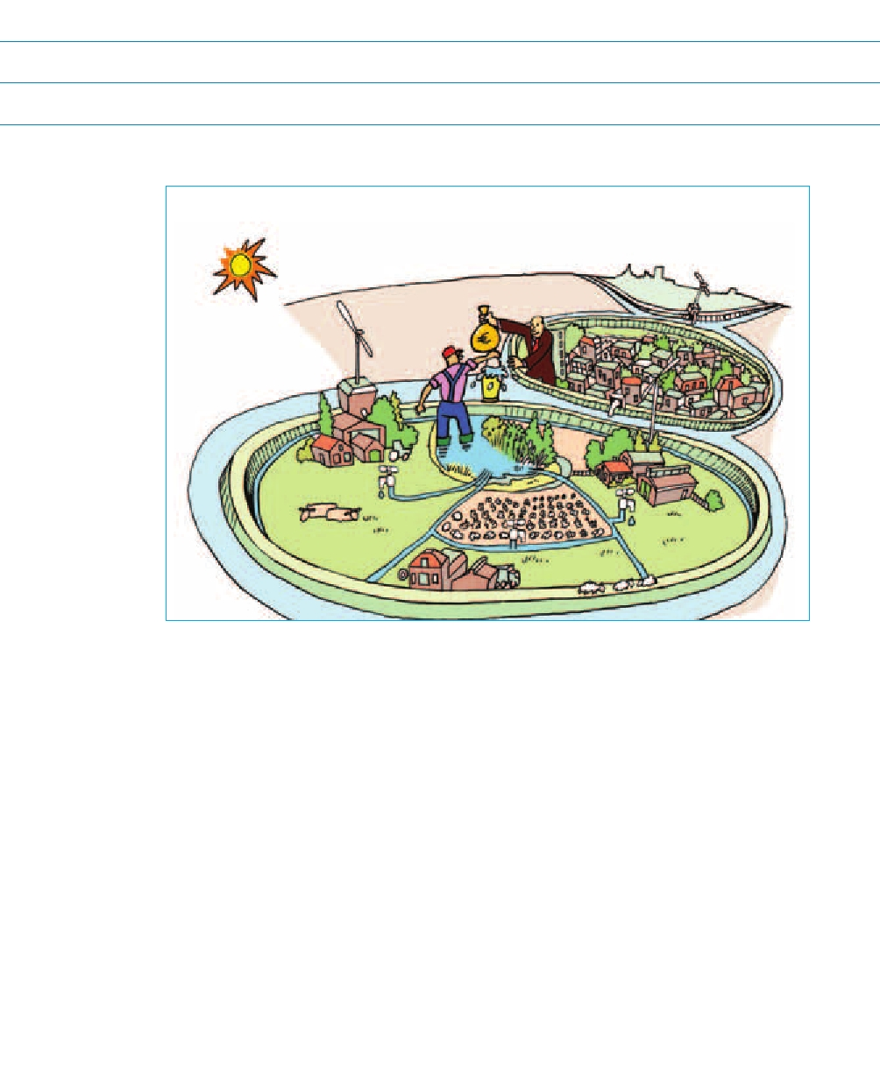
Reference
www.waterhouderij.nl



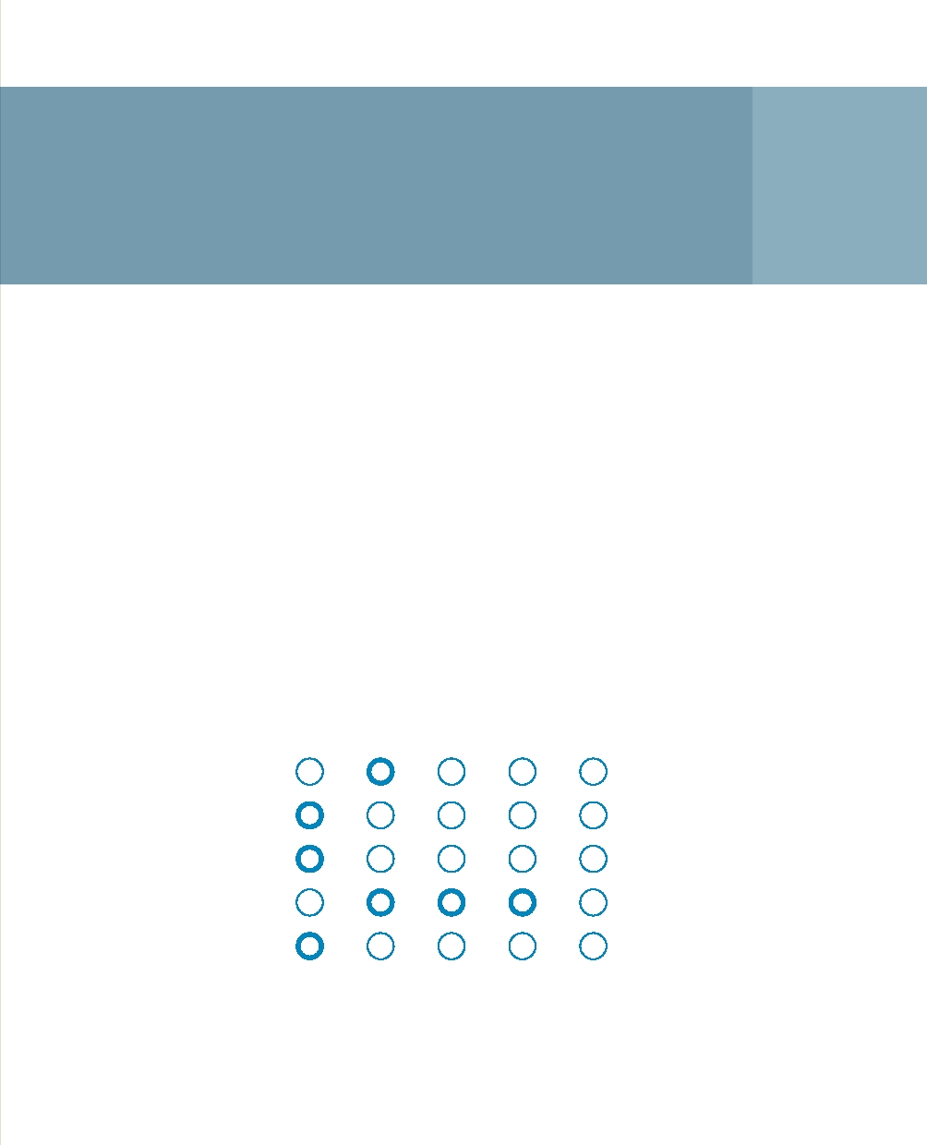
Sensors to prevent drought damage 11

In a field with crops, monitoring instruments can supply real-time data about soil moisture and nutrient levels. A decision-support system can use those data to generate recommendations for farmers about when, where and how much water and fertiliser should be used.

Principle
Good crops depend crucially on the right amount of soil moisture and the presence of nutrients. Obviously, these values are not constant. They change continuously as a result of a range of processes such as the weather and crop uptake levels. In the past, it was often difficult for farmers to take timely action because they lacked hard information. Sub-optimal levels of water and nutrients availability would only become apparent when crops were harvested, during long periods of drought, or if the crops were visibly ailing.

Strong Moderate Neutral Moderate Strong

Demand Availability

Hard Soft

Local International

Structural Emergency

Opposition Acceptance

Developments in information technology and improvements in our understanding of agrohydrology mean that it is increasingly possible to combine sensor information about, for example, fields with other information such as weather forecasts based on satellite data. A decision-support system combines all this information and analyses it. The result is a recommendation to irrigate or water fields, or to apply fertilisers.

Case studies
In 2010, the Dacom organisation received the innovation award from 'Partners for Water'. On the basis of this sensor technology, Dacom supplies online advisory services to farms throughout the world. Using those services, farmers can monitor their crops and take action throughout the growing season. A range of studies have shown that this saves water and improves crop yields. In the absence of continuous monitoring of this kind, crop irrigation/watering is often excessive, resulting in nutrient run-off, but also rot and disease. Conversely, irrigating or watering crops too late during dry periods can often inflict irreversible damage.

The WaterSense project brought together approximately 70 Dutch farmers and a large number of partners to work on the development of a decision-support system for managing water quantities and quality. Once again, hundreds of sensors are being used to measure soil moisture. The results will be combined with precipitation data and weather forecasts. A pilot farm is experimenting with crop sprinkling, a range of fertilisation rates and crop protection products.

Applicability in the Netherlands
The innovation described here illustrates how individual water users can prevent drought damage at the field scale. The technology supplies the user with the information required to anticipate drought adequately. By doing so, it makes a group of water consumers (in this case the farmers) more resilient, reducing their dependence upon supplies of fresh water from, for example, the main water systems.

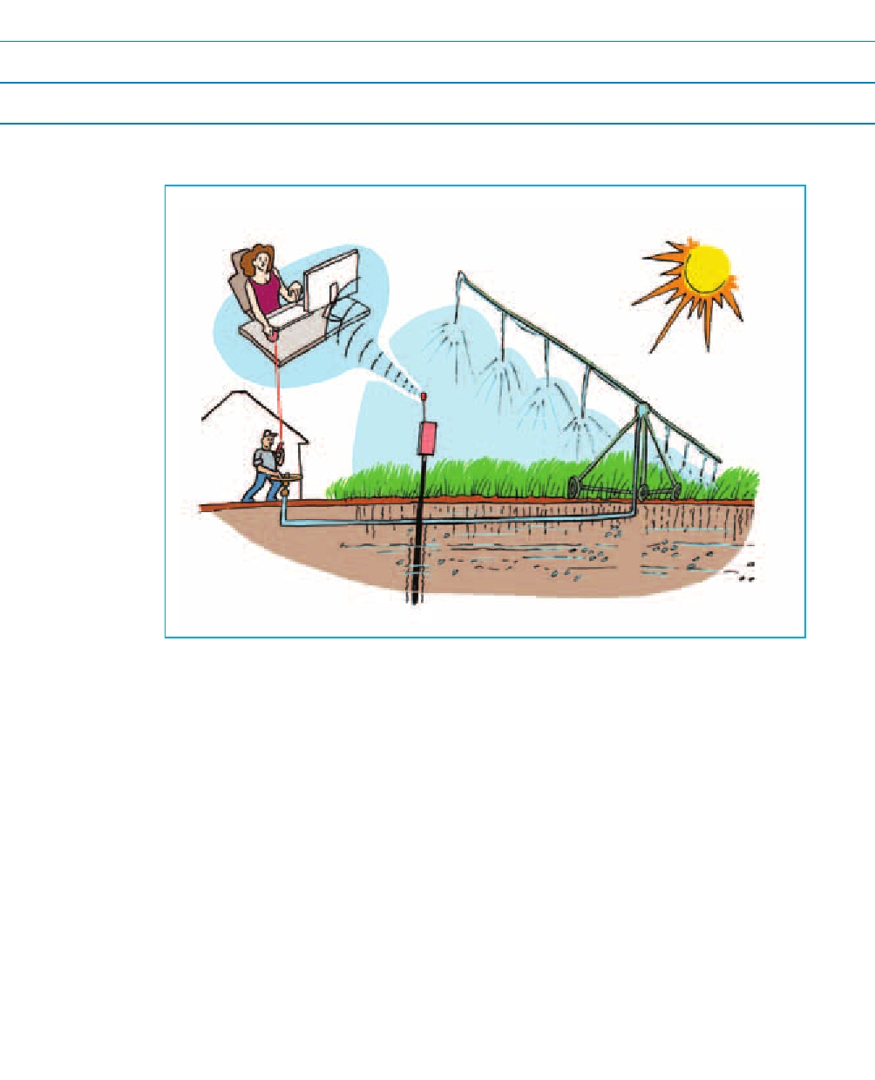
Reference
www.projectwatersense.nl, www.thesoilcompany.nl
Hadders, J., 2009. Agri Yield Management, the next revolution in agriculture, DACOM
www.partnersvoorwater.nl

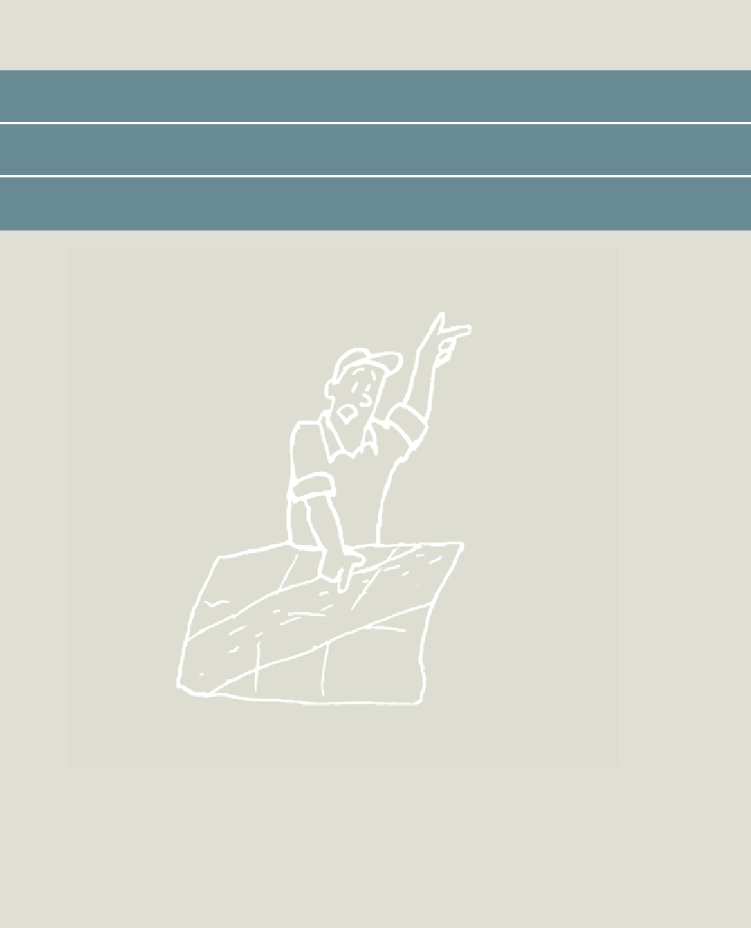

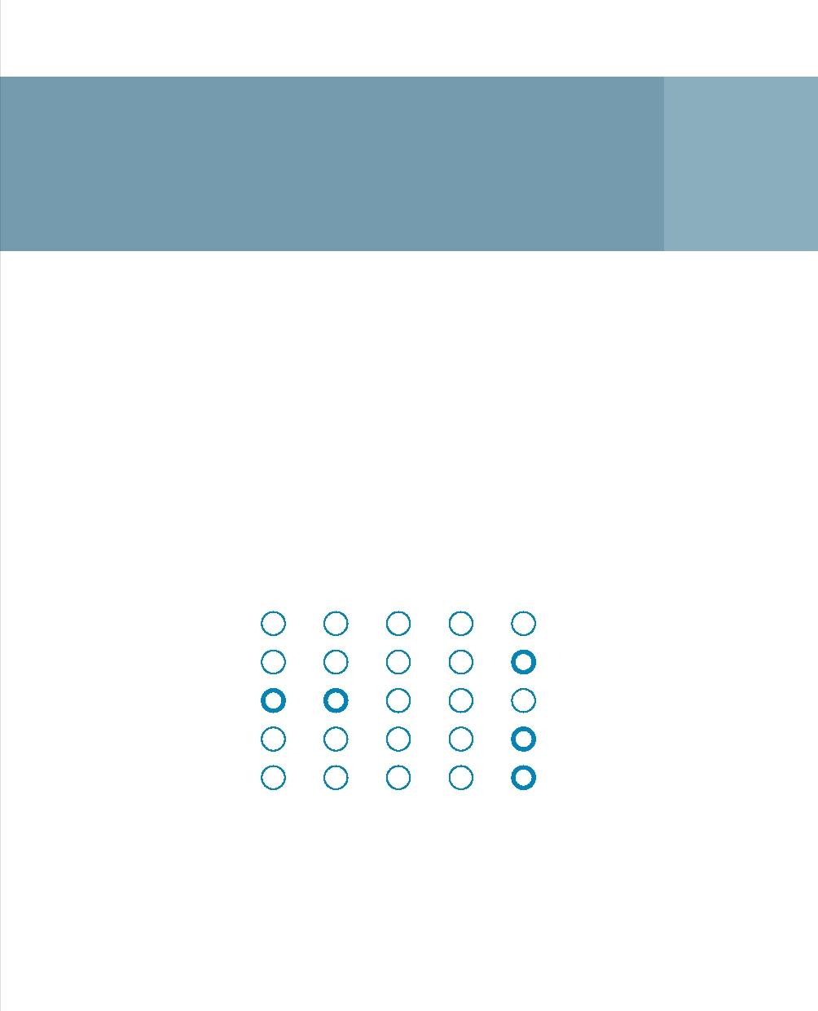
Wet and dry insurance
12

Insurance companies make financial payments to companies who suffer losses of income if they are unable to do their work during droughts or if their products are damaged.

Principle
Against the backdrop of climate change, uncertainties relating to water can only increase: the forecast is for a rise in the number of 'extreme events'. More floods and droughts mean a loss of income for those companies whose operations depend on a given water situation, such as farmers and inland shipping.

Strong Moderate Neutral Moderate Strong

Demand Availability

Hard Soft

Local International

Structural Emergency

Opposition Acceptance

For centuries, insurance has been a tried and trusted way of protecting oneself against unexpected high costs. For the person taking out insurance, the financial risk is covered; insurers have the opportunity to make a considerable profit. Insurance can also be useful when it comes to water. Private individuals and farmers, but also water management authorities or even Rijkswaterstaat, can take out insurance for water damage resulting from floods and droughts.

Taking out insurance against drought is based on the assumption that some of the drought risk cannot be eliminated by means of mitigation and adaptation. Considerable debate has focused on the relationship between the insured business, the insurer and the water management authority whose task it is to maintain the water conditions the business wants.

Case studies
Since 2010, arable farmers have had the option of taking out insurance for all weather-dependent damage to crops in open fields resulting from extreme conditions. LTO and Achmea have teamed up to produce the 'Mutual Weather Damage Insurance.' Water-related insurance has also been introduced successfully in developing countries. Kenya and Ethiopia are examples of countries where a range of businesses and funds are offering insurance to smallholders in areas where drought can easily affect crops and cattle. Using satellite images, insurers can check from a distance whether the damage being claimed has actually been caused by drought.

Applicability in the Netherlands
Arable farmers have in recent times been able to take out insurance for all types of weather damage. However, insurance may also be of interest for other parties. For example, water management authorities may be able to take out insurance against damage to infrastructure caused by excessive water or water scarcity.

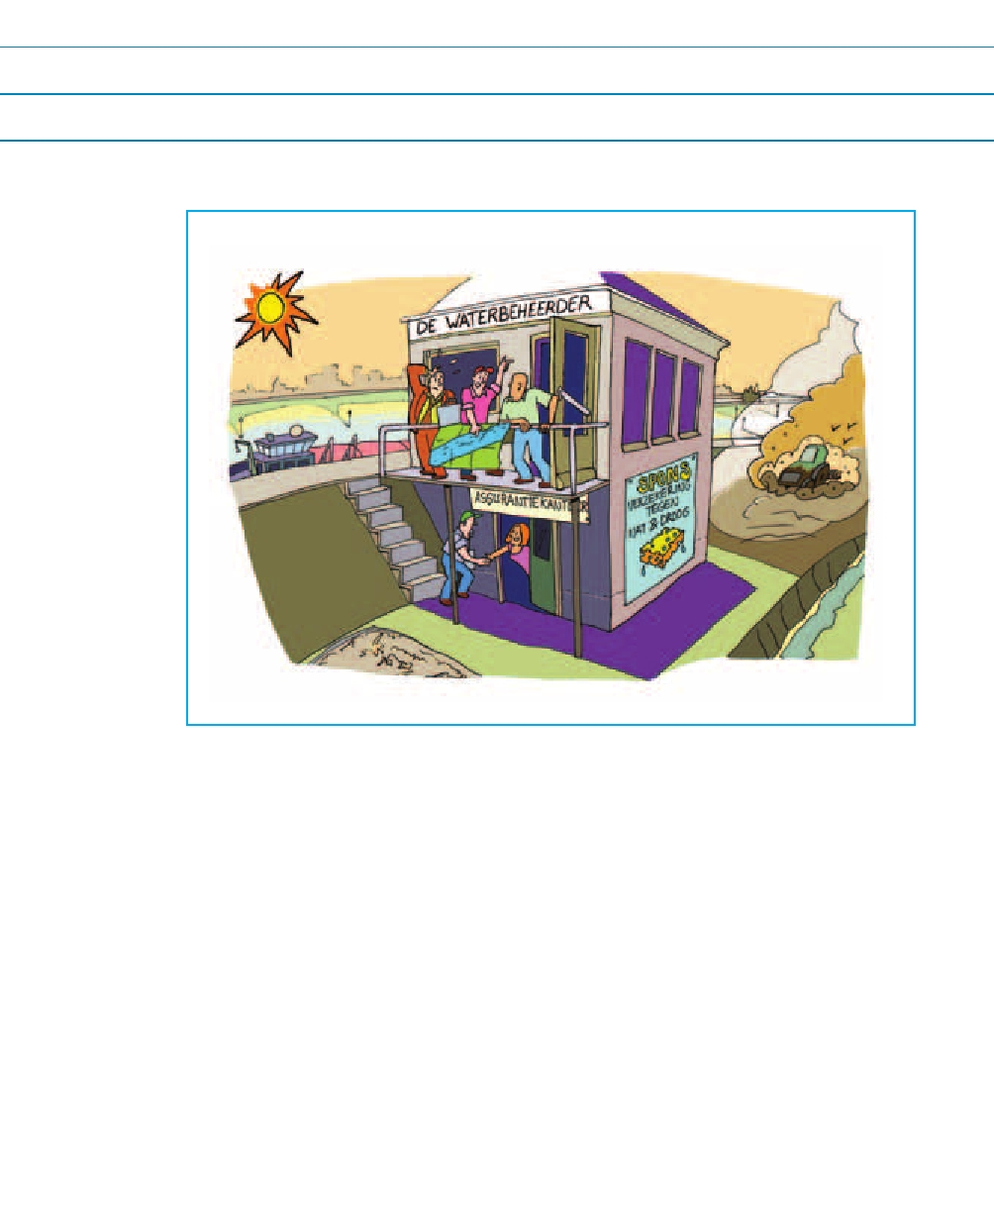
Reference
Osgood, D. and D. Warren, 2007. Drought insurance in Malawi in Climate Risk Management in Africa: Learning from Practice, Hellmuth, M.E., Moorhead, A., Thomson, M.C., and Williams, J. (eds), International Research Institute for Climate and Society (IRI), Columbia University

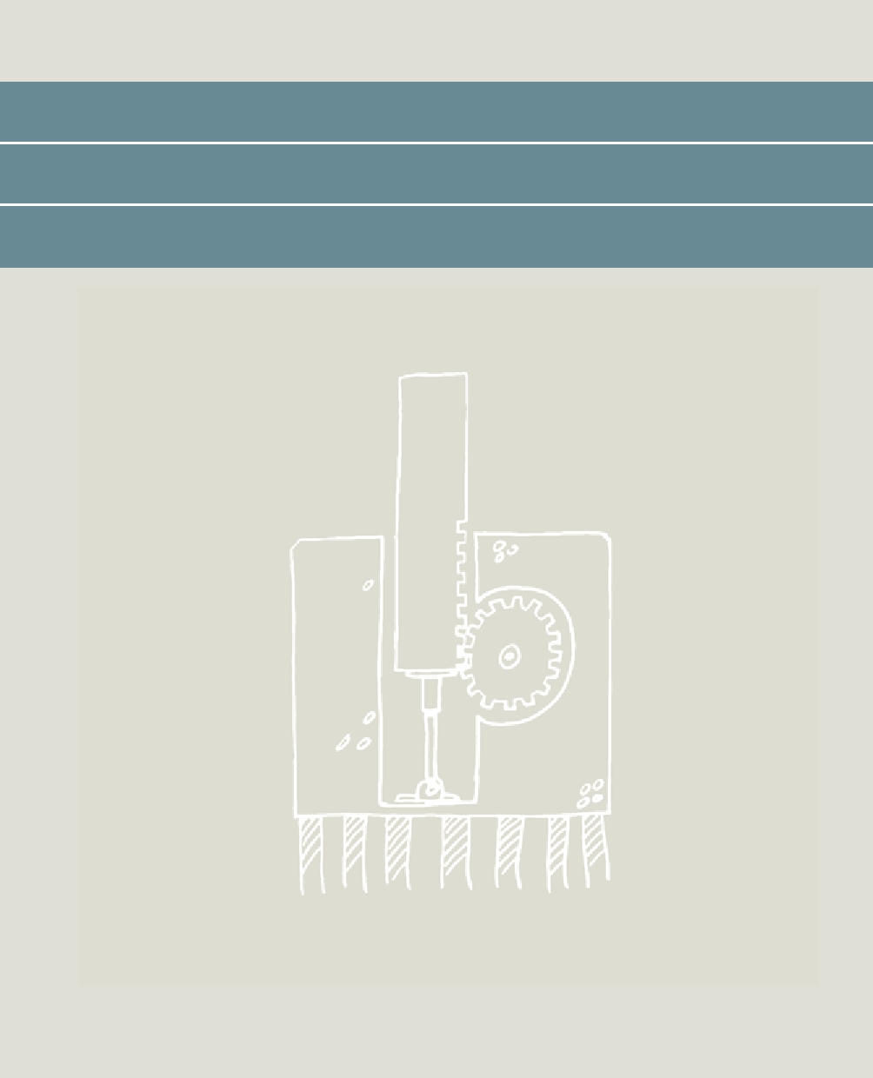

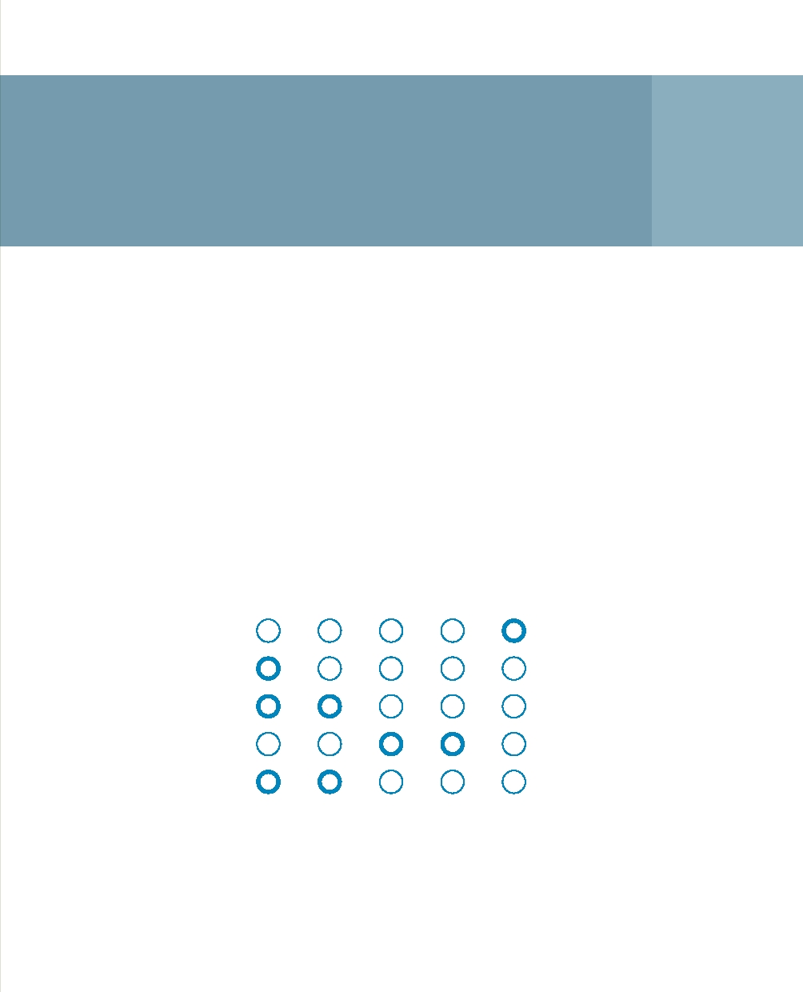
Limiting salt intrusion
in estuaries 13

This cluster of innovations limits undesirable salt intrusion into river estuaries without interfering with other river functions such as shipping.

Principle
To a certain extent, salt water from the sea penetrates into the fresh river water. This is a natural process which is a feature of almost every river estuary in the world. Discharge dynamics and river morphology are the determinant factors. The combination of sea-level rise and longer periods of low river discharges will further salt intrusion in the future. Salt intrusion is often undesirable because we, and nature, depend on the fresh water in the estuaries.

Strong Moderate Neutral Moderate Strong

Demand Availability

Hard Soft

Local International

Structural Emergency

Opposition Acceptance

A range of innovative measures for combating salt intrusion have been explored in the New Waterway near Rotterdam. Obviously, we do not want these measures to interfere with river traffic or limit access to the port of Rotterdam. Options are:
• The deployment of a movable barrier, inflatable rubber dams, extended and specially designed groynes and bed screens generate a turbulent water current that limits the density flow (see figure).
• Storing salt water in deep subsurface wells in the port area. Constant desalination of these wells will be required.
• The refinement and optimisation of the entire supply system in the Delta system: the temporary closure of the various branches using existing locks, timing this operation in such a way that the salt does not penetrate where it is not wanted.

Case studies
The salinisation of river estuaries is a global problem. For example, the metropolis of Khulna in the densely-populated delta of Bangladesh has more and more problems with salinisation. Even though the city is 130 kilometres land inwards, the river there is increasingly salt. An expensive operation involving the moving upstream of the river inlet for drinking water supplies has provided a provisional solution for the urgent shortage of drinking water.

Applicability in the Netherlands
As part of the WINN programme Water Management of the Future, a project group involving water management authorities, the Rotterdam Port Authority, Rijkswaterstaat South Holland and Deltares is using numerical models or scale models to upgrade the techniques mentioned for the specific situation in the New Waterway for a possible pilot project. The experience acquired here will establish a sound foundation for innovative approaches to limiting salt intrusion in other places in the Netherlands. And because there is strong demand worldwide for the solutions, we will be able to export this Dutch expertise and knowledge to many other areas where river estuaries involve major economic interests.

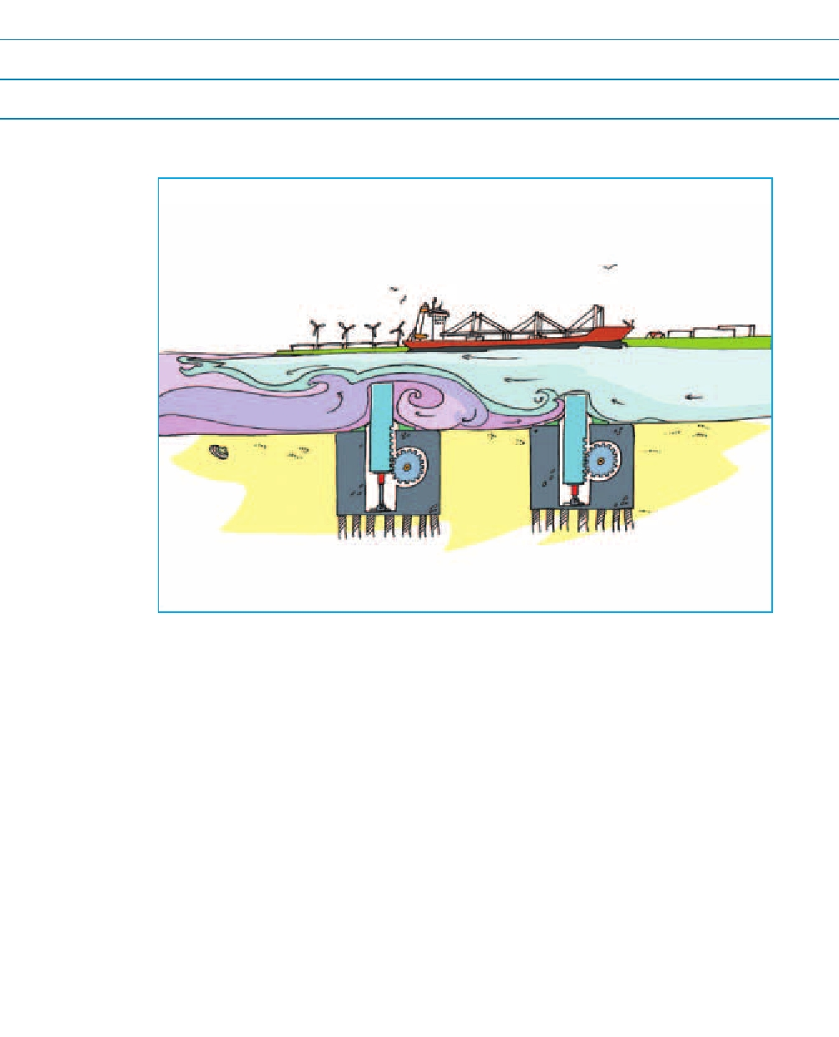
Reference
Rijkswaterstaat, 2010. Newsletter about salt-fresh issues, No. 1 (in Dutch)



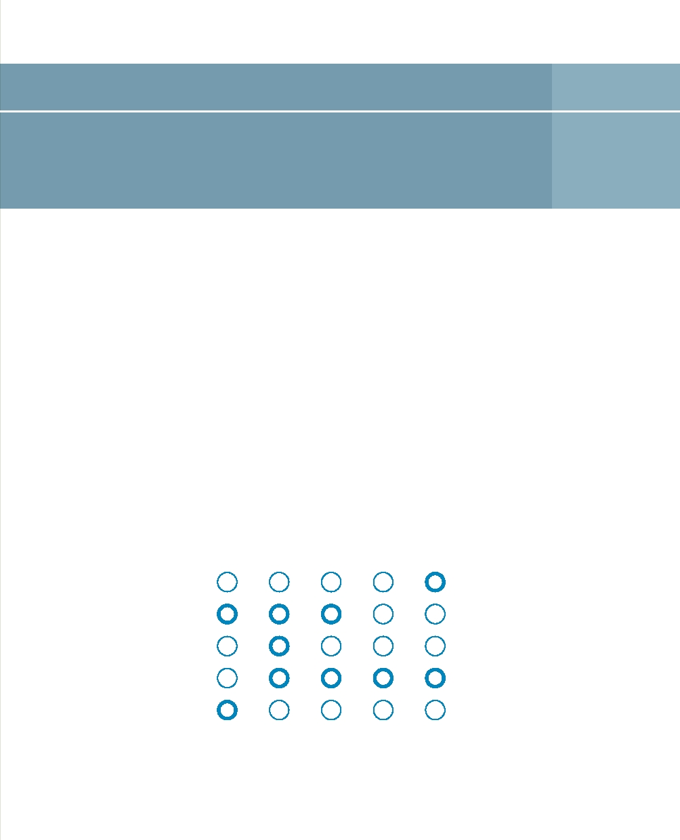
Inland shores 14

The term 'inland shores' refers to water storage areas behind dikes around the IJsselmeer, often of a planned kind, that have a clear water management function. Considerable variations in levels (of more than one metre) are possible here and so these areas can store water during periods of excess, and release it during periods of scarcity.

Principle
The IJsselmeer area plays an important role at the national level for strategic freshwater supplies. In anticipation of future developments, the Delta Committee has advised extending this function by allowing the level of the IJsselmeer to rise by up to 1.5 metres in line with the sea level. However, this rise will have a negative impact on the ecology and the infrastructure in the surrounding area. A wish has been expressed for alternatives. Inland shores may be an alternative or welcome addition to the recommendations of the Delta Committee.

Strong Moderate Neutral Moderate Strong

Demand Availability

Hard Soft

Local International

Structural Emergency

Opposition Acceptance

Seasonal storage behind the dikes takes up space, particularly when volumes of any significance are involved. On the other hand, this option represents a more future-robust structure for the Netherlands against the backdrop of climate change. In addition, numerous policy goals for the IJsselmeer will reap the secondary benefits. In short, this represents a larger investment but also one with more added value.

The idea is feasible in the long term if we can introduce numerous, smart, functional combinations such as living and working near and on the water, nature development, recreation, and sustainable agriculture and fishing. Inland shores can develop into sustainable residential and working areas with new opportunities for the regional economy in a climate that is getting warmer. In addition, the concept is a source of innovations in the field of climate adaptation.

Case studies
A range of large and small water storage projects involving a multi-functional use of space are in the preparatory stages and/or being implemented in Netherlands. Examples are the Meerstad, Zuid-Westflank Haarlemmermeer and Climate Buffer projects. In these projects, the water management function is often subordinate to the issue of freshwater supplies. Freshwater supplies play a central role in the inland shore concept.

Applicability in the Netherlands
This concept means that, in addition to vertical water storage, we can also look at horizontal storage options outside the boundaries of the main water system. At the moment, the primary flood defences constitute a hard boundary, separating land and water, people and nature, and organisations. Inland shores blur that boundary in line with the new philosophy for flood risk management. This concept works if water management authorities work together without being confined to their own areas, and can generate enough benefits. There are still many questions about the opportunities and benefits afforded by inland shores that we can probably only answer by conducting practical trials (probably on a small scale). The polder was reworked in 2012-2013 in accordance with the inland-shore concept. The Water Experiment will start in 2014.

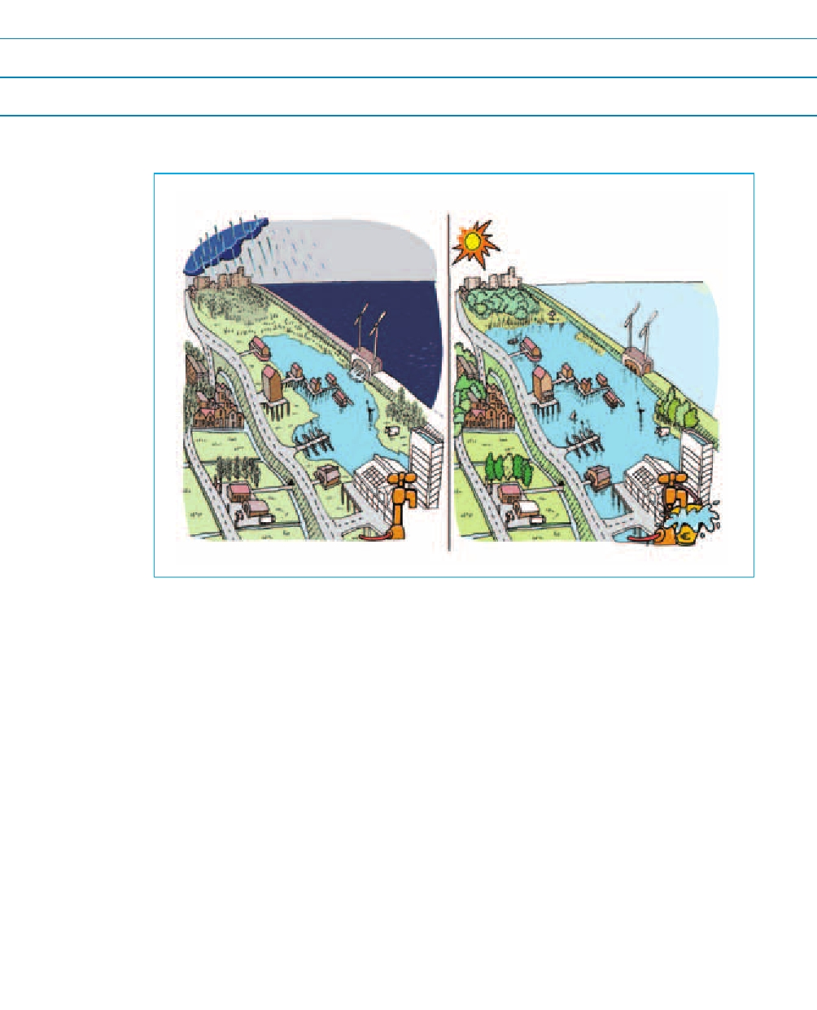
Reference
Rijkswaterstaat Centre for Water Management (with Deltares), 2009. Opportunities can be find behind the shore, WINN Inland Shore working conference, 27 August2009, Rijkswaterstaat Lef Future Center (in Dutch)
http://public.deltares.nl/display/CAW/Achteroevers

14 Inland shores 69

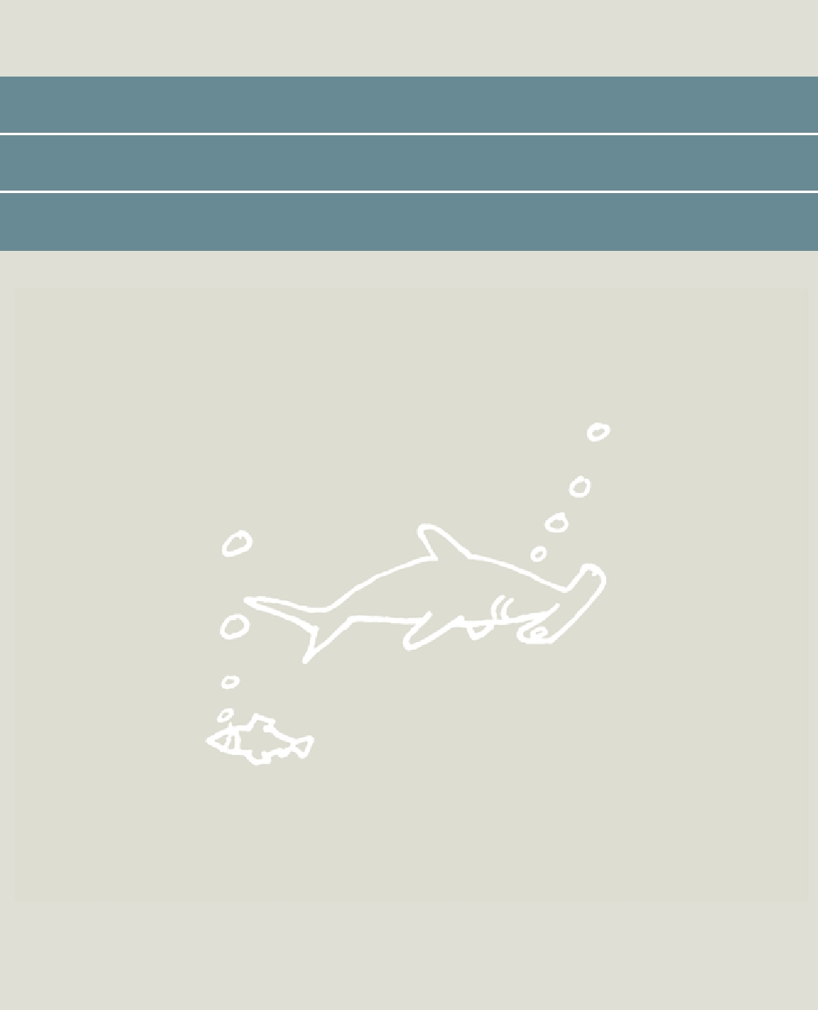

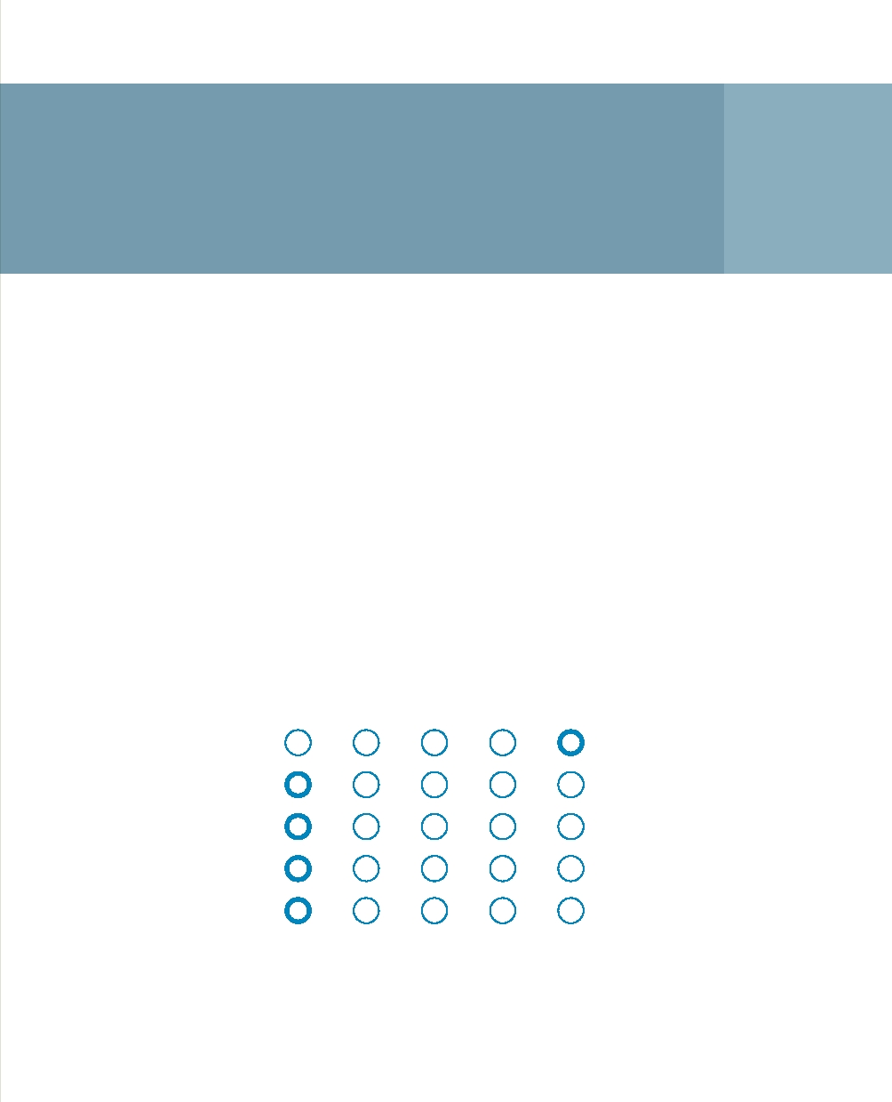
Underground
hydraulic barrier 15

The underground hydraulic barrier is a system involving the artificial infiltration of fresh water into the groundwater to counteract the underground penetration of seawater. Barcelona has been working with a system of this kind since 2007, leading the way in Europe.

Principle
Barcelona is located on top of the LLobregat aquifer. This aquifer is an important element in the city's supplies of drinking water. As a result of over-exploitation, there has been increasing salinisation from the sea since the 1960s. The introduction of 14 infiltration wells in a row along the coast makes it possible to generate hydraulic overpressure that acts as a hydraulic 'underground dike'. The water that is infiltrated through the wells is a combination of pre-treated river water and waste water.

Strong Moderate Neutral Moderate Strong

Demand Availability

Hard Soft

Local International

Structural Emergency

Opposition Acceptance

The system costs €23 million to install. In addition to the infiltration wells, there are also wells for groundwater monitoring. The monitoring shows that the groundwater quality in the aquifer is improving and that the system is working well. The process of salinisation has been reversed and the water in the groundwater system is getting fresher.

Case studies
The deep infiltration of pre-treated surface water to prevent the salinisation of groundwater by over-exploitation is a familiar technique that is used in the Dutch dunes. However, Barcelona is the only known location in Europe where infiltration wells have been located in such a way that they form a large-scale hydraulic barrier.

Applicability in the Netherlands
Because of its low-lying location, the Netherlands is also facing the challenge of the underground infiltration of salt water from the North Sea. The technology could be used to combat excessive intrusion where the latter causes severe problems. The area concerned is a strip along the coastline where seawater is coming in through the main water system. The concept is not a solution for diffuse brackish seepage in polders.

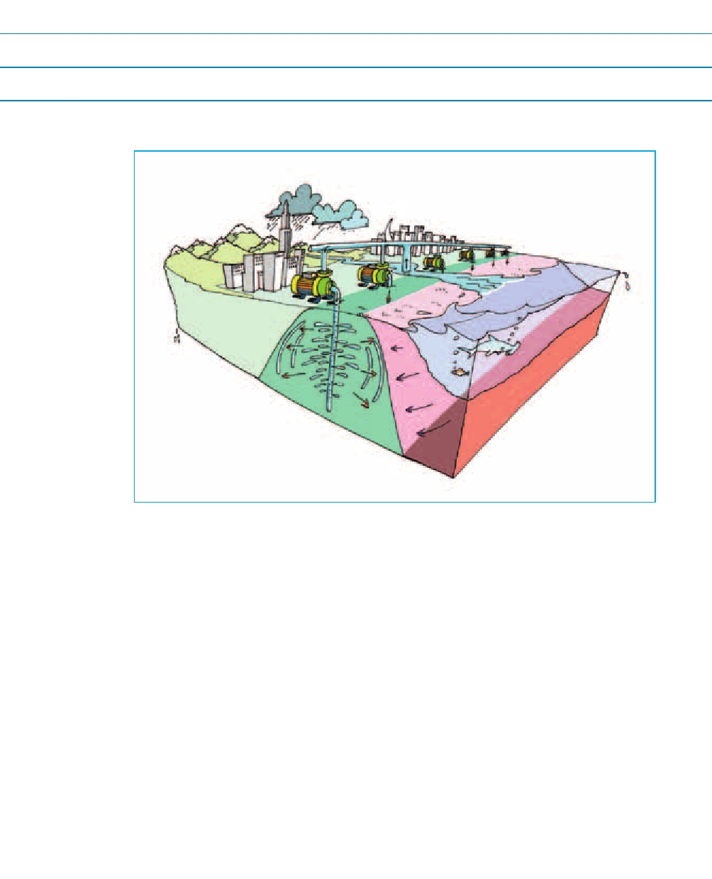
Reference
Teijón, G., Tamoh, K., Soler, M., and L. Candela, 2009. Treated wastewater reuse for a seawater intrusion hydraulic barrier implementation in the Llobregat delta aquifer (Barcelona, Spain), First phase, Options Méditerranéennes, No. 88, Technological Perspectives for Rational Use of Water Resources in the Mediterranean Region

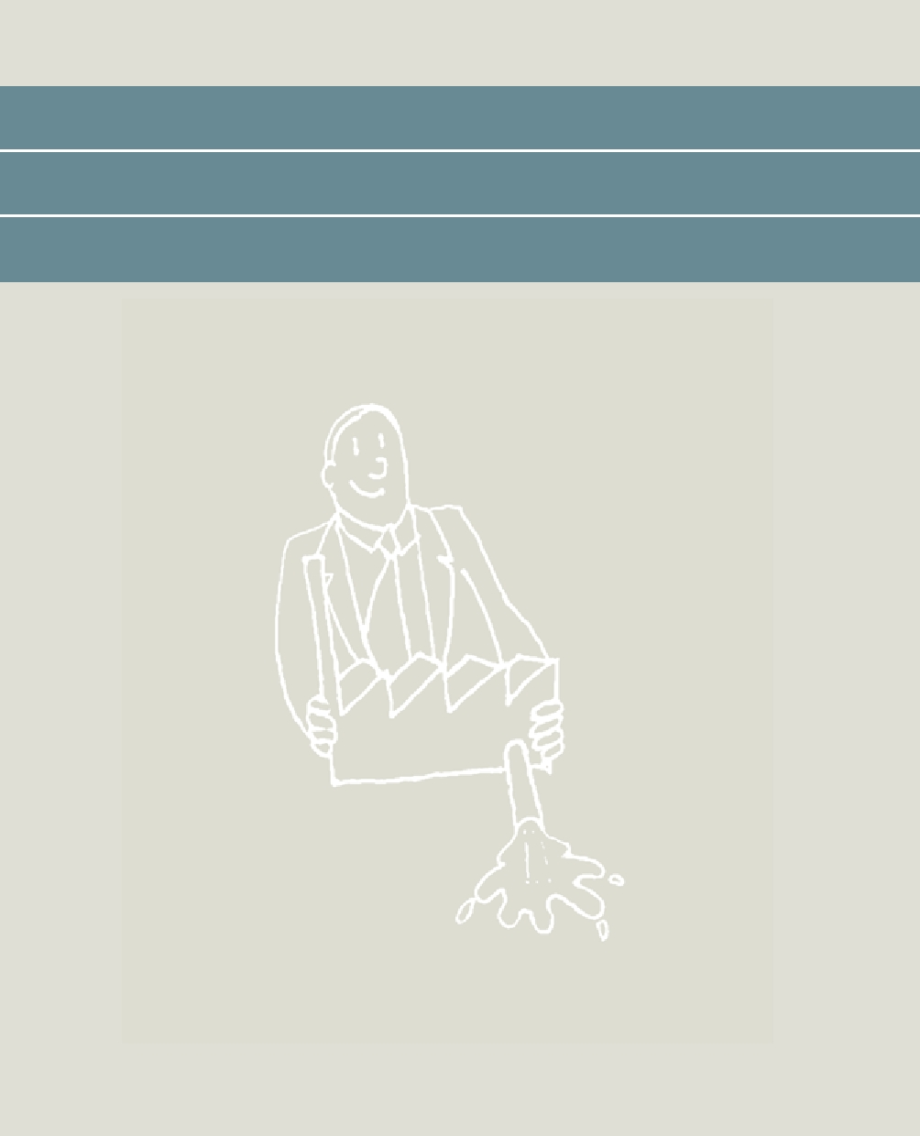

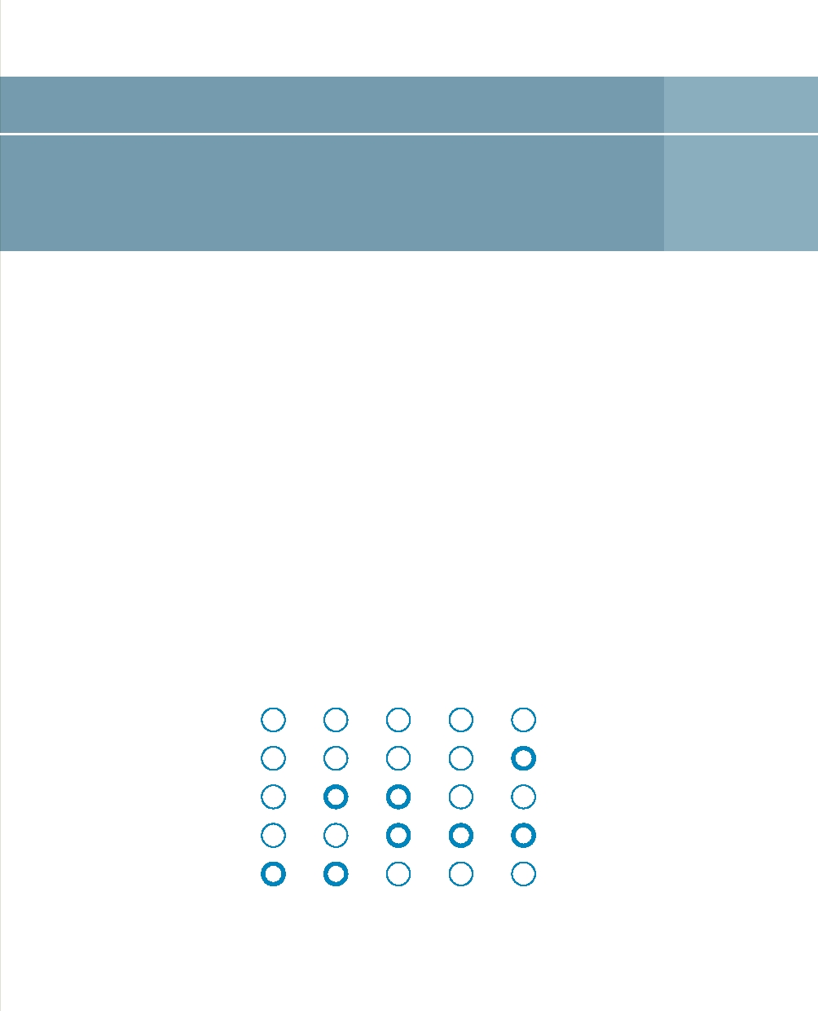
Drought sessions 16

A drought session is a workshop at which regional Rijkswaterstaat departments team up with water management authorities to explore the available options and innovation requirements when water scarcity increases in a specific area. The aim is to establish a short-term innovation agenda for freshwater supplies that is properly coordinated with the primary Rijkswaterstaat process in collaboration with the water management authorities.

Principle
The sense of urgency relating to drought and water scarcity in the Netherlands is, in practice, still limited but it is on the increase. We have had dry years in the Netherlands, but the problems were usually manageable, particularly for the main water system. Instruments have now been developed to anticipate emergencies with drought and water scarcity. For example, Rijkswaterstaat and water management authorities have 'drought' scenarios, and we have a national priority list7 and regional implementation plans associated with that list.

Strong Moderate Neutral Moderate Strong

Demand Availability

Hard Soft

Local International

Structural Emergency

Opposition Acceptance

In addition, work is being conducted on a Drought Early Warning System for operational water management. However, because we have hardly had to deploy instruments of this kind at all until now, it is unclear to what extent such systems can actually be used to best effect in practice if the worst comes to the worst. What management information is genuinely needed? Are the systems adequately operational and coordinated? What are the specific difficulties in a particular area for which an innovative solution is required? Do the water management authorities themselves have specific suggestions for areas that they think should be targeted by the Rijkswaterstaat innovation programme for drought?

Case studies
The first drought session was in November 2010. The area managed by Rijkswaterstaat Utrecht and RWS Eastern Netherlands, with the relevant water management authorities, was selected for study. A description of this session can be found on the Drought Session website.

Applicability in the Netherlands
In themselves, drought sessions are not really innovations but they can generate the information that leads to drought innovations by water management authorities. The sessions can also contribute to enhancing our understanding of the impact of drought on planning and management. Proper interaction between the managers of the main system and the regional systems is of the essence. Drought sessions are not isolated activities. They are part of the process in which Rijkswaterstaat and regional water management authorities are increasingly working together to tackle the challenges of the future. Rijkswaterstaat hopes that drought sessions will encourage regional collaboration at the operational level. This could become a regular activity for the Rijkswaterstaat Centre for Water Management.

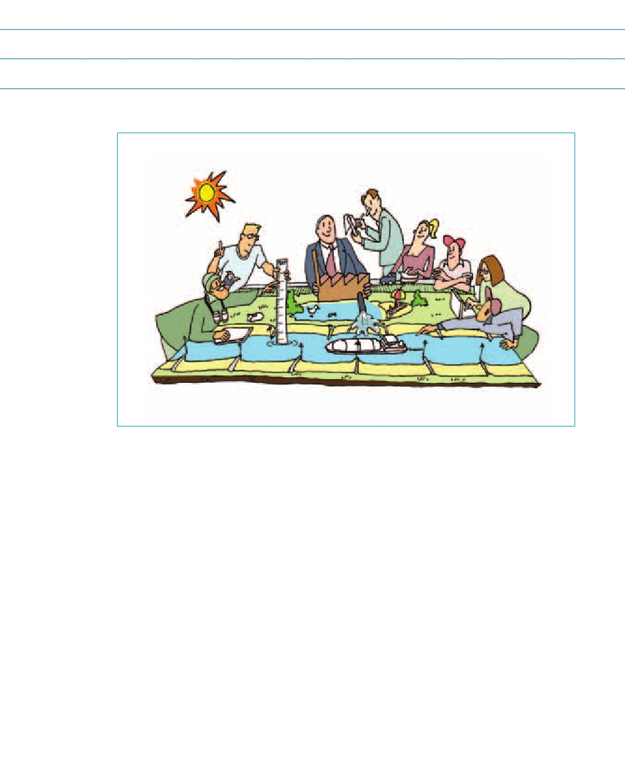
Reference
http://public.deltares.nl/display/CAW/Droogtesessies

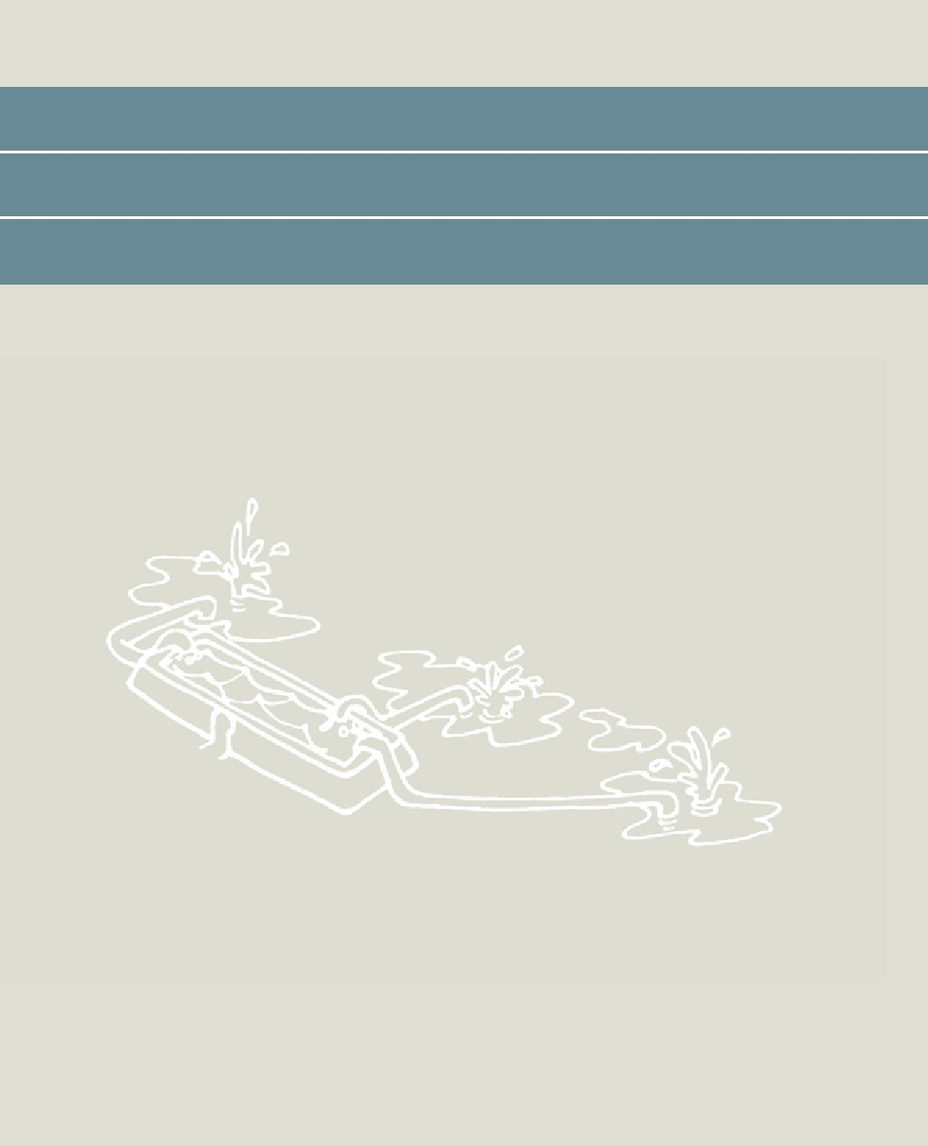

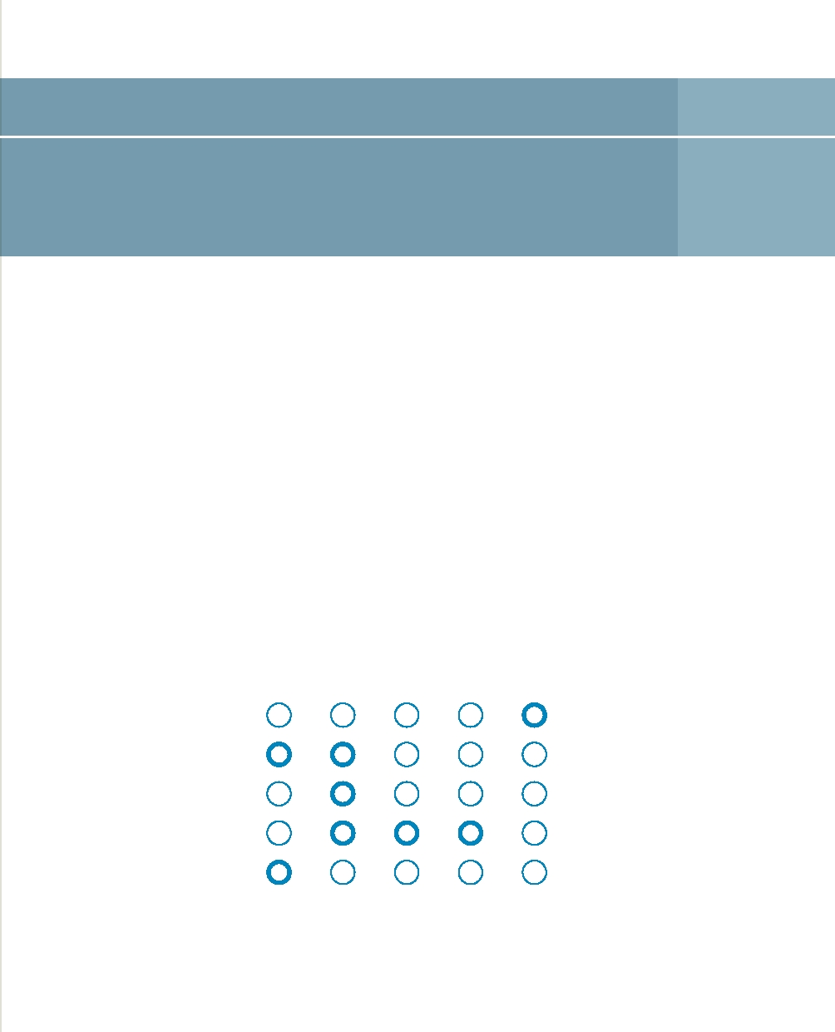
Water from the shore 17

This solution focuses on making better use of the seepage water from the 'Brabantse Wal' for freshwater supplies for fruit growers in Zuid-Beveland using a system of retention, storage and transport.

Principle
In Zuid-Beveland, supplies of fresh water are limited because local water is often brackish. The climate here favours fruit growing but demand for fresh water is high. The drinking water company Evides installed a special agricultural water pipeline in 1991. It brings water from the Meuse river to Zuid-Beveland. During periods of drought, however, water transport capacity has proven inadequate. Furthermore, this facility is relatively expensive. The Brabantse Wal is located near Zuid-Beveland. Less groundwater is being extracted from that location and so more fresh seepage water is now available. At the moment, this water is still being lost to the Western Scheldt.

Strong Moderate Neutral Moderate Strong

Demand Availability

Hard Soft

Local International

Structural Emergency

Opposition Acceptance

It is possible to store the fresh seepage water in basins for freshwater supplies in the Reigerbergsche polder. In the future, the water can also be transported to locations for fruit growing further west. The transportation of seepage water can also be combined with road construction or road maintenance. Creek ridges can be used to store water underground. They are already being used for the storage and extraction of fresh water in an area where water is predominantly brackish. Research has been planned to look at the extension of storage capacity in the creek ridge systems.

Case studies
The package of innovative measures is now being studied for Zuid-Beveland. The resulting knowledge and experience could be used for a range of other locations in the Southwestern Delta where fresh water is not used and where storage in creek ridges is possible.

Applicability in the Netherlands
We expect to see higher water tables as a result of climate change around a number of lateral moraines, as in the case of the Veluwezoom. This could create problems in built-up areas. The useful exploitation of the probable increases in seepage flows around those lateral moraines addresses two problems. It prevents problems with groundwater, and transporting and/or storing the captured seepage water is one way of tackling drought.

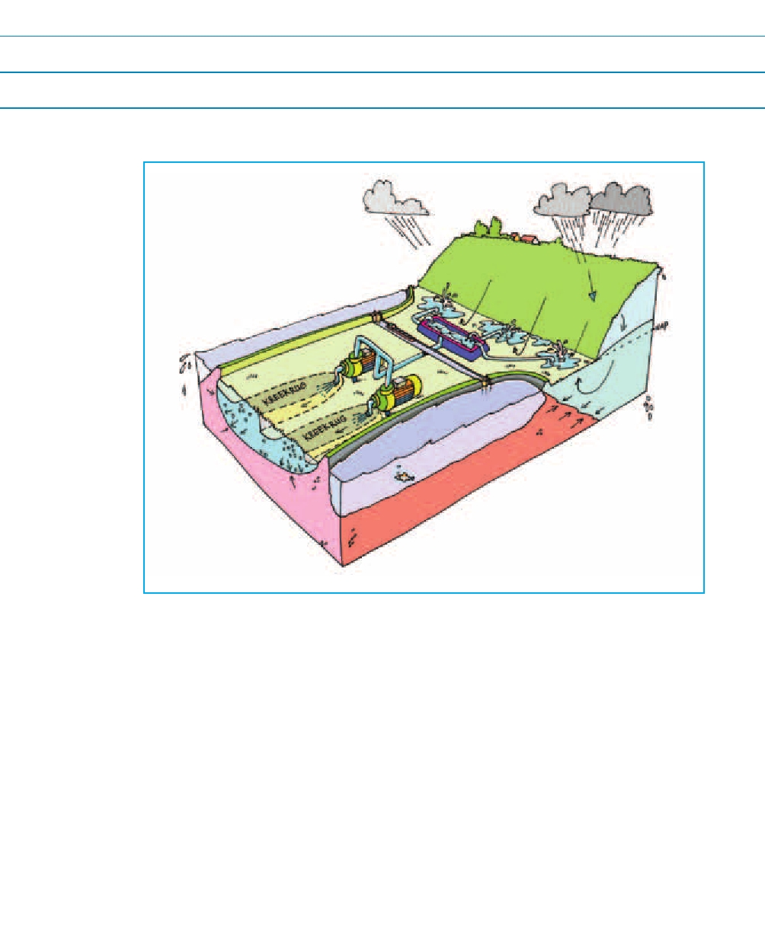
Reference
Knowledge for Climate and the Southwestern Delta, 2009. Freshwater supply and demand in the Southwestern Delta, an analysis (in Dutch)

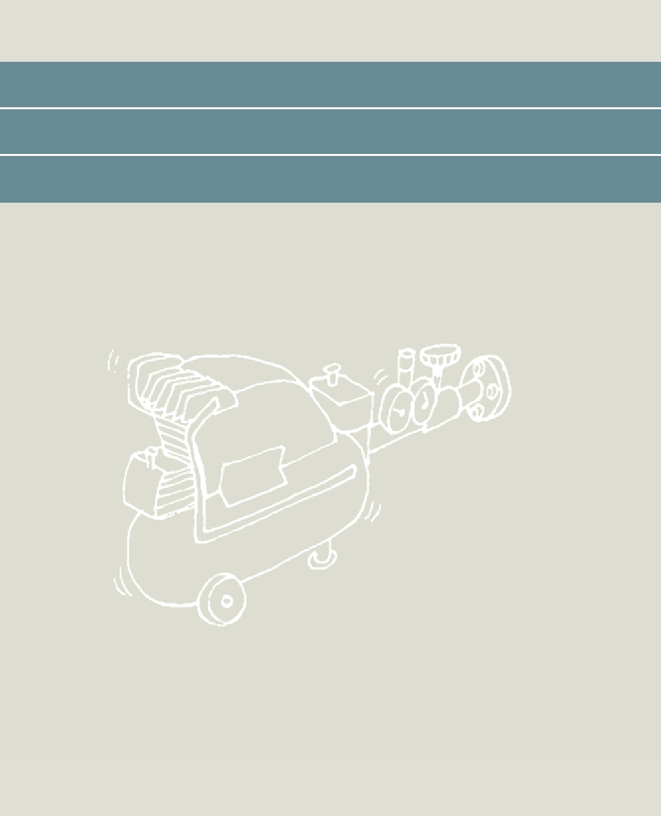

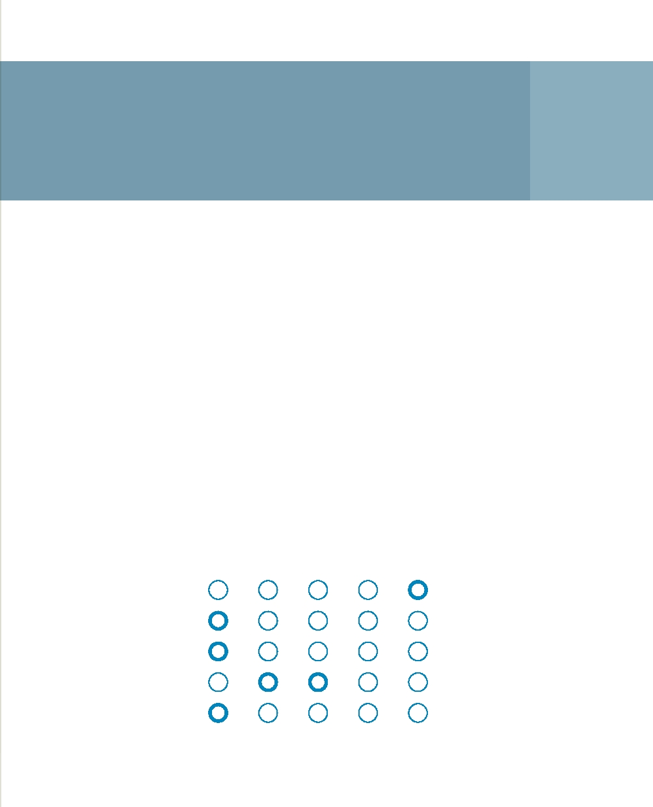
Bubble screens and other
adaptations to locks 18

Bubble screens and other adaptations to locks prevent salt leakage.

Principle
Locks are major sources of salt intrusion since fresh and salt water are in immediate contact with one another here. Even if there is almost no difference in the water level on either side of a lock, or even if the fresh side is higher, salt water flows in the direction of fresh water as a result of differences in density. A review was conducted to identify possible techniques to reduce this salt leakage. The identified techniques are:
• A bubble screen combining air and water injection, optimisation of air and water flows;
• Flaps/brushes on ship routes;
• Changes to threshold height in locks;
• Reducing lock volume by raising the bed;
• Leaking ebb gates (small flow of fresh water to salt outer harbour);
• Use of basins to divert salt water and storage temporarily using density flow.

Strong Moderate Neutral Moderate Strong

Demand Availability

Hard Soft

Local International

Structural Emergency

Opposition Acceptance

Case studies
Bubble screens have been installed in a range of locks in the Netherlands, including the Volkerak locks, the locks in the Afsluitdijk Barrier Dam, and the locks in IJmuiden. Success has been varied, primarily as a result of the occasional lack of clear guidance in management practice.

Tests in 2010 in the Afsluitdijk Barrier Dam did result in the optimal management of bubble screens in combination with freshwater injection. Other measures are also available, such as ebb gates that have higher leak flow volumes. In the case of the Volkerak locks, a range of measures will be elaborated against the background of the salinisation of the Volkerak-Zoom Lake.

Applicability in the Netherlands
In the Netherlands, a range of lock projects are being developed, such as the new locks in IJmuiden and in Terneuzen, where salt intrusion represents a major challenge. A selection from the measures listed above could make an important contribution to coping with this issue. Locks are a feature in many deltas worldwide and so we can apply the knowledge we acquire about these transitions from fresh to salt water internationally.

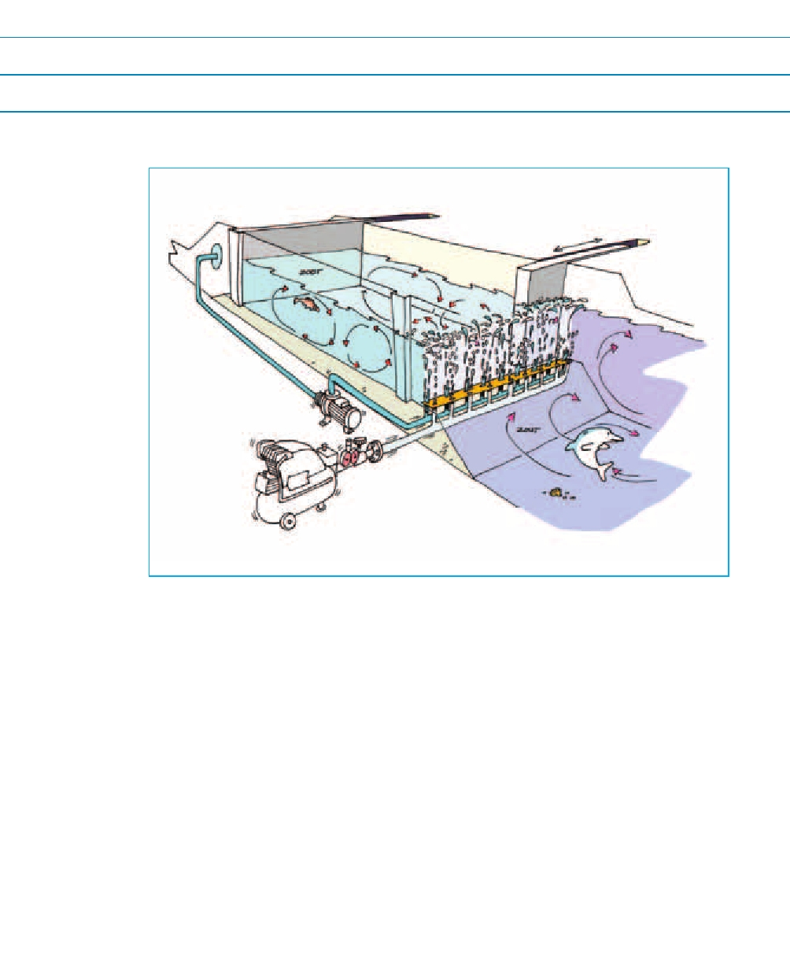
Reference
Rijkswaterstaat Bouwdienst, 2008. Measures to counteract salt intrusion at locks, Plan Study of Water Quality in Volkerak Zoom Lake (in Dutch)

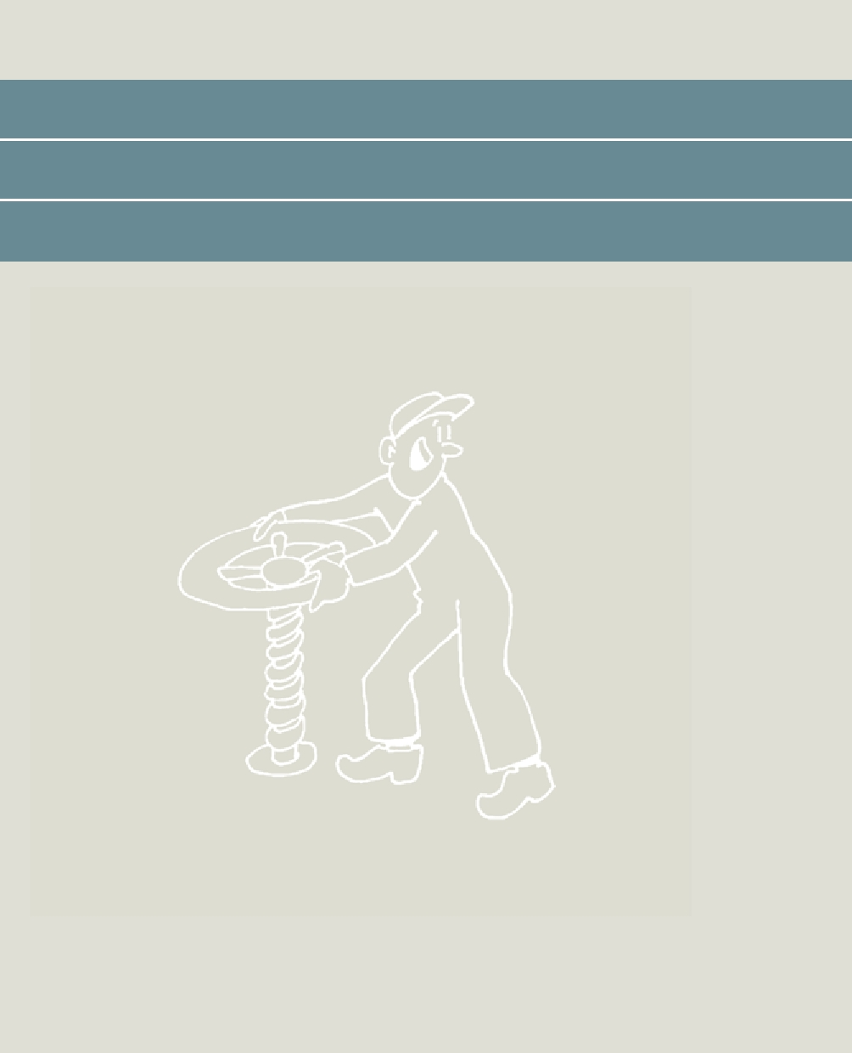

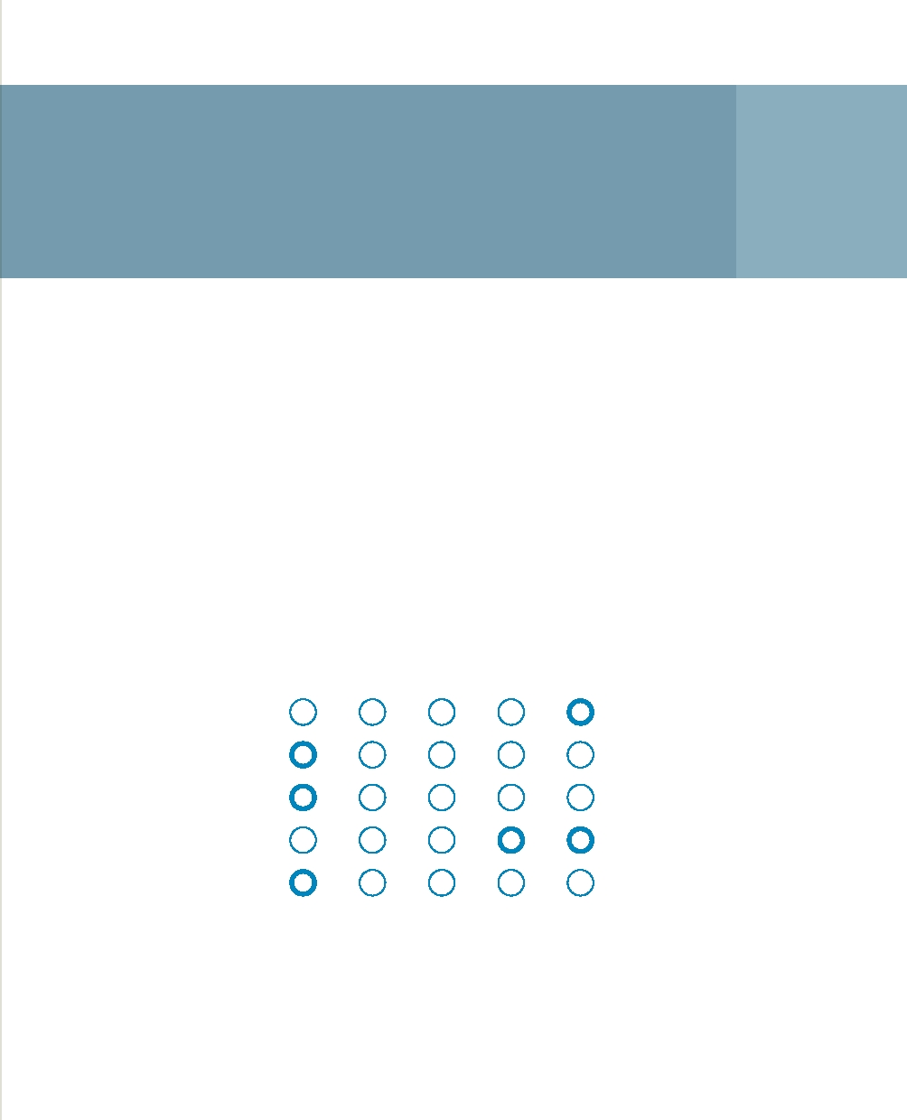
Level-controlled
drainage 19

Farmers working on dry sandy land can use level-controlled drainage to manage the groundwater level in their fields, and therefore to retain soil moisture for longer during dry periods.

Principle
The excess rainwater during Dutch winters lead to shallow groundwater levels. The conventional approach to agricultural drainage means that the water flows quickly from the land into downstream waterways and brooks during the winter months. During wet winters, this has already resulted in flood problems on various occasions. In the summer, rapid run-off can actually dry out agricultural land and the surrounding nature.

Strong Moderate Neutral Moderate Strong

Demand Availability

Hard Soft

Local International

Structural Emergency

Opposition Acceptance

The solution involves retaining water in a more flexible way at the level of individual fields. Using sluices around farmland and combined drainage methods, individual farmers can fine-tune the groundwater level much better. A lot of experience was acquired in the 1990s with the use of sluices around farmland in drainage ditches. This approach works well but the numerous sluices reduce flows in the ditches, leading to all sorts of ecological difficulties. Combined level-controlled drainage does not suffer from this drawback because drains cannot empty directly into ditches. The water first enters a collection drain, in which the level can easily be adjusted. That allows farmers to maintain higher or lower groundwater levels as required.

Moisture levels can be maintained better using this new drainage method, and so obviate the need for irrigation. During dry periods, it is possible to use the drains to allow rainwater collected at the location to infiltrate into the soil: reverse drainage, in other words. The system also saves on fertiliser costs because less water containing dissolved phosphate and nitrogen drains out of the system.

Case studies
At present, research is taking place in a large number of pilot projects looking at the effectiveness of various forms of flexible water-level management. In these projects, farmers are teaming up with the Dutch Agriculture and Horticulture Organisation (LTO), water management authorities and research institutes such as Alterra, Deltares and KWR, as well as engineering firms such as Artesia, FutureWater and Grontmij. A range of studies are looking at how flexible water-level management can prevent unwanted peat oxidation and the associated land subsidence.

Applicability in the Netherlands
This innovation is based on shallow water storage underground on a seasonal basis at the field scale. The option of regulating water management on one's own land and also of helping to prevent water scarcity and flooding, while saving costs at the same time, appeals to farmers. In the area managed by the Peel en Maasvallei water authority, which is leading the way in the Netherlands in the field of level-controlled drainage, there has been a rapid increase in the number of farmers switching to this form of drainage. This technically straightforward, robust and financially feasible approach to water management has the potential for widespread application in the Netherlands.

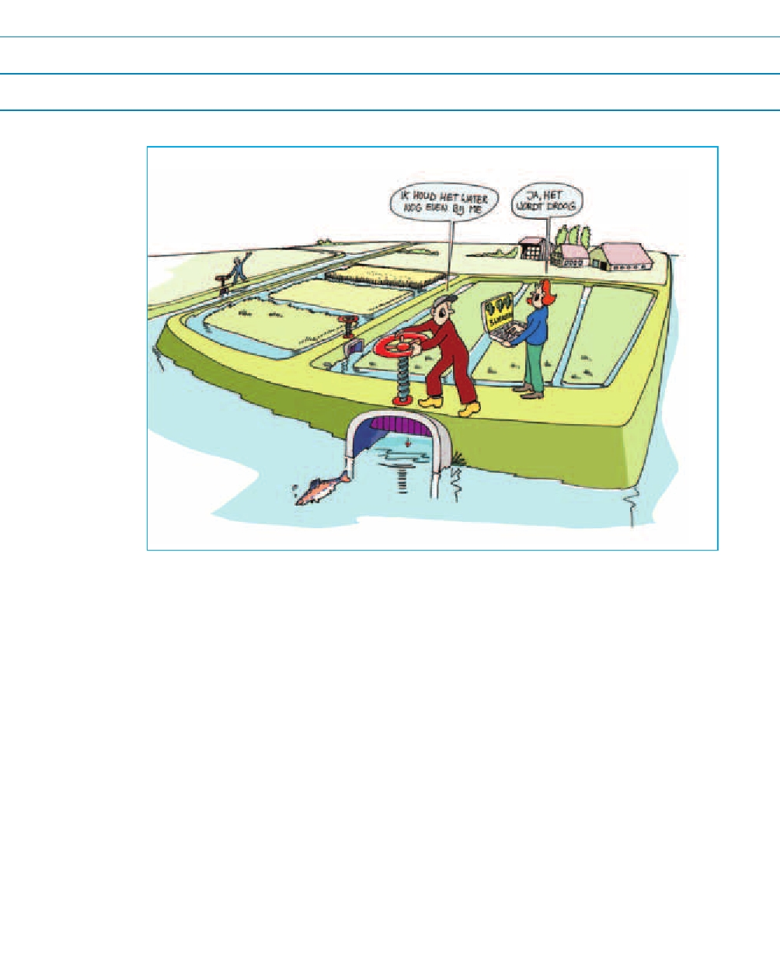
Reference
Waterschap Peel en Maasvallei, information folder for Level-Controlled Drainage (in Dutch)
www.waterschappeelenmaasvallei.nl

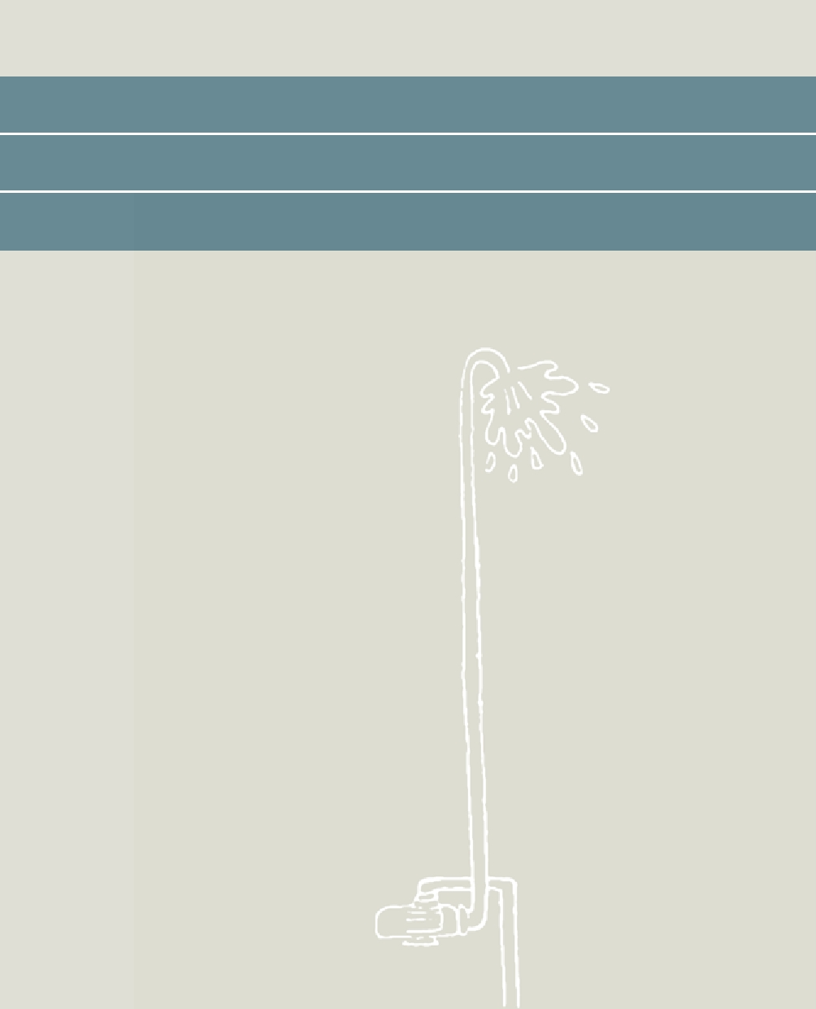

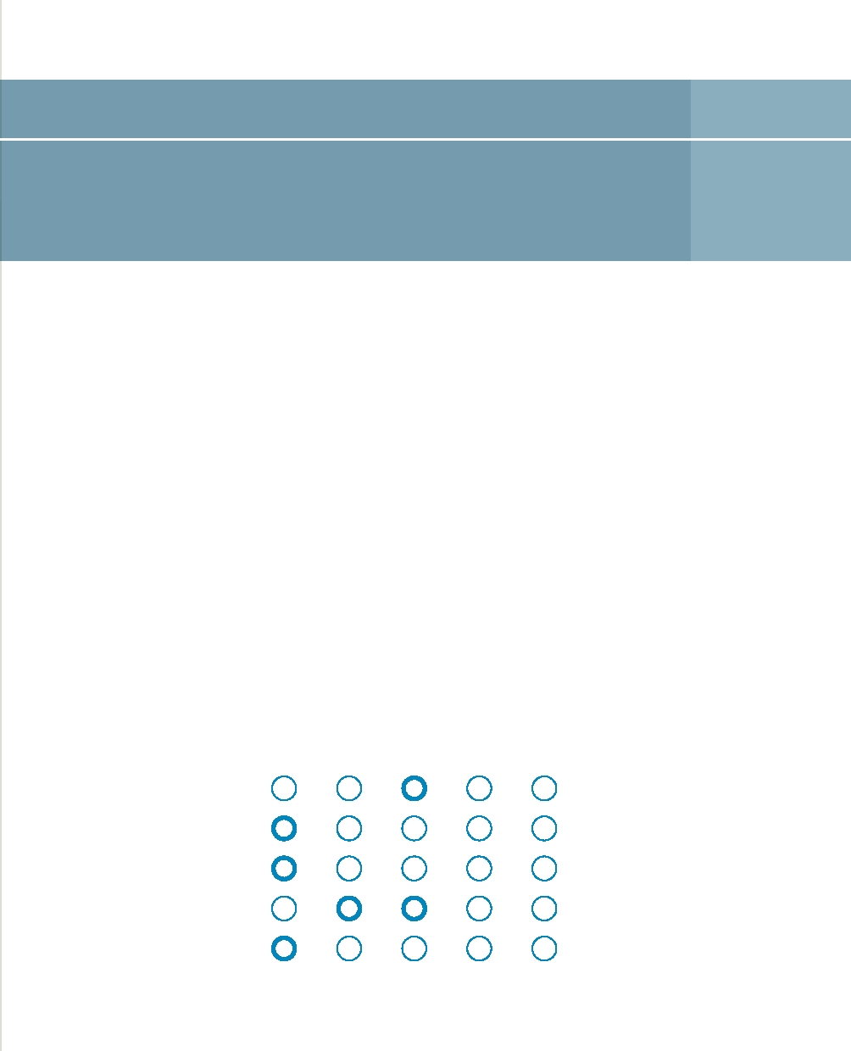
Keeping Fresh 20

The local, underground storage of excess winter rainwater so that horticulture under glass is kept as water-neutral as possible.

Principle
The greenhouse horticulture sector uses water intelligently. Reservoirs collect rainwater that falls on the roofs of the greenhouses, preventing large peak flows in the local area and also creating free stores of water for irrigation. Coastal areas in particular, where fresh water is not in plentiful supply and is indeed scarce during dry periods, can benefit from freshwater storage. However, storage on the surface takes up land where greenhouses could be built. This underground solution saves space and that is one reason it is relatively cheap.

The challenge in coastal areas consists of developing an infiltration and management system to store fresh water in a bubble in a salt aquifer. This may involve intelligent planning using extraction and injection wells so that the underground bubble of fresh water is maintained and is available for repeat extraction. Sensor information controls this pumping process.

Strong Moderate Neutral Moderate Strong

Demand Availability

Hard Soft

Local International

Structural Emergency

Opposition Acceptance

Case studies
Storing water underground is a method that is enjoying increasing interest. This idea is not new. More than 15 years ago, the greenhouse horticulture sector in the Westland was already storing rainwater or desalinated deep groundwater in shallow aquifers.

In the beginning, there were disappointments, such as wells getting blocked; the underground bubbles of fresh water sometimes flowed away or floated up. In the light of that experience, engineering firms now know better how to prevent these difficulties. There are also examples of places where collected rainwater is not stored in the subsurface but in water-tight cellars immediately below the greenhouses.

Applicability in the Netherlands
It is expected that demand for fresh water storage will increase in the future, and not just in greenhouse horticulture, given the expectation of drier summers. In the winter, excess fresh water in these areas can be 'harvested' in various ways, for example from high-water peaks (in ditches) or from roofs. The expectation is that there will be many more opportunities for the storage of rainwater in the future. The goal of sustainable building will generate a new impetus for rainwater storage and re-use, for example in the area of lavatory flushing.

In greenhouse horticulture, there are opportunities to make operations more sustainable in the form of all sorts of innovative technological measures and the intelligent use of natural processes. The recycling of any excess nutrients used in the irrigation water and an intelligent approach to energy recovery and aquifer thermal energy systems are other approaches that can make a greenhouse environment largely self-sufficient.

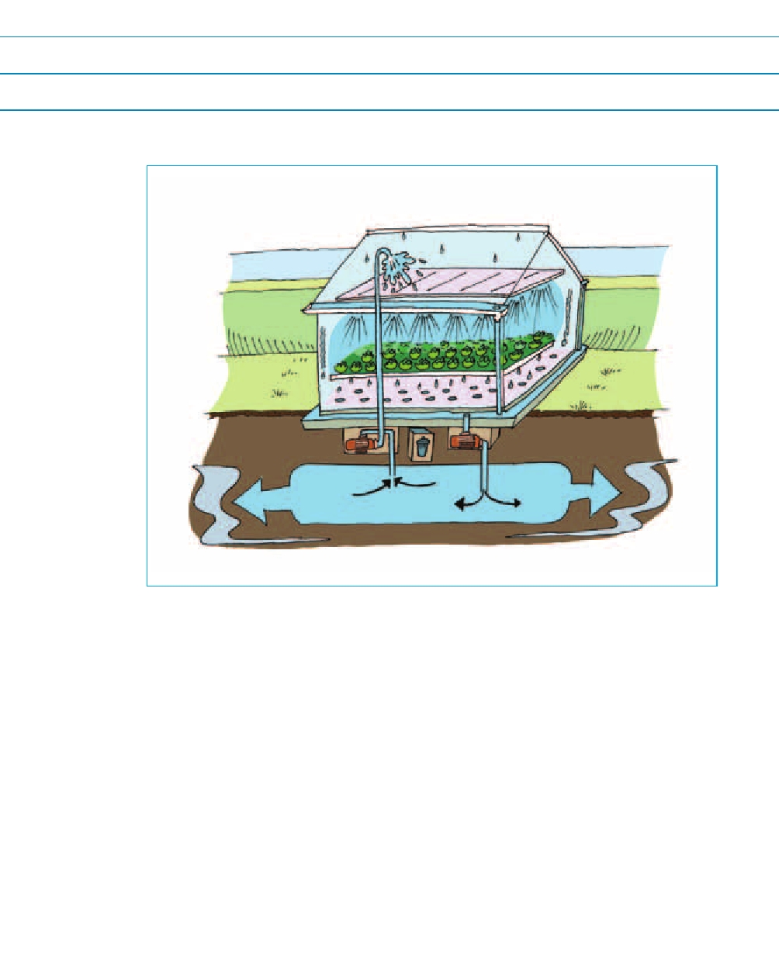
Reference
Wageningen Universiteit, 2007. Kasza: closed water circuits in greenhouses, Under Glass, No. 2 (in Dutch)


Afterword

The drought innovations that have been listed and classified in this booklet show the direction of future innovation opportunities. The focus would seem to be primarily on improving water supplies, and less on reducing water demand (75%/25%). The measures described are often of the hard, technological variety rather than soft measures such as raising awareness and changing behaviours (65%/35%). Innovations involving a large-scale spatial component have often proven difficult to implement. This overview shows that the emphasis is on applications at the local level (fields and small sub-catchments) and less on higher scale levels (70%/30%). In addition, we have seen that innovation primarily targets the prevention of drought or the reduction of vulnerability to drought, rather than the acceptance of, and compensation for, damage (80%/20%).

The question that arises is whether we can meet the drought challenge in the Netherlands over the years to come using this array of measures. And who will be implementing the various measures? In some cases, water managers have clear responsibilities. For example, the implementation of infrastructural drought measures in the main water system is primarily a task for Rijkswaterstaat. Individual water management authorities will be responsible for other activities. However, this issue is less clear-cut with other drought measures. In those cases, water managers will have to team up with other water stakeholders, for example in the context of the Delta Programme; elsewhere, the initiative will actually be much more with the general public and industry.

We hope that water managers, and everyone else who can contribute to the prevention of drought, or who has to face up to the challenges presented by drought, will be inspired by these ideas to devise creative and effective solutions. This publication is, above all, a call for a dialogue. It is clear that drought is high on the agenda of many parties, and that people are developing solutions. It is important now to establish intelligent combinations. Let us start with a dialogue between the various water management authorities both in the Netherlands and abroad, and between water management authorities and other water stakeholders.

Abbreviations

BOS:
DEWS:
DLG: FAO:
FEWS: WFD:
ICT:
LCW: LTO: NHI:
RWS:
UNESCO-IHE:
UVA:
UN:
WECC:

Decision-support system
Drought Early Warning System
Rural Area Department
Food and Agriculture Organisation (UN)
Flood Early Warning System
Water Framework Directive
Information and Communications Technology
National Coordination Committee for Water Allocation
Dutch Agriculture and Horticulture Organisation Dutch Hydrological Instruments
Rijkswaterstaat
UNESCO Institute for Hydraulic Engineering
University of Amsterdam
United Nations
West European Climate Corridor

References

1. Milieu en natuurplanbureau, 2005. Effecten van klimaatverandering in
Nederland

2. Beersma J. T.A. Buishand en H. Buiteveld, 2004. Droog, droger, droogst.
KNMI/RIZA bijdrage aan de tweede fase van de Droogtestudie Nederland.
KNMI-publicatie, De Bilt

3. Kuijper, M., Oude Essink, G.H.P., Binsbergen, R., van en B. Minnema, 2005.
Kijkje in de toekomst: klimaatveranderingen en verzilting in de provincie
Zuid-Holland in beeld gebracht, H2O, Nr. 8, pag. 33-37

4. Oude Essink, G.H.P., van Baaren, E.S., and P.G.B. de Louw, 2010. Effects of
climate change on coastal groundwater systems: A modeling study in the
Netherlands, Water Resources Research, Vol. 46

5. Global Water Intelligence & OECD, 2008. Global Water Tariff Survey,
Global Water Intelligence, Vol. 9 (9)

6. Moncur, J.E.T, 1987, Urban water pricing and drought management,
Water Resources Research, Vol. 23 (3)

7. Ministerie van Verkeer en Waterstaat, Directoraat-Generaal Water &
Rijkswaterstaat, Waterdienst, 2009. Waterhuishouding en waterverdeling
in Nederland, Redactie: Arnold, G., Kielen, N., Bos, H., Luijn, van F.,
and R. Doef


Annex
Other drought measures

Many more measures could be mentioned that have the potential to contribute to addressing the challenges of drought and water scarcity. A few measures have been listed here without further elaboration. To a certain extent, they are also measures that are outside the remit of water managers.

a. Changing the drought and salt tolerance of crops using gene technology;

b. The selection by farmers of crops with higher drought and salt tolerance levels;

c. The selection by farmers of crops with a lower evaporative demand;

d. The extension of agriculture in saline areas to include things like saltwater aquaculture;

e. Efficient irrigation ('flood irrigation' is generally used in developing countries; the excess water evaporates without plants benefiting, or it infiltrates into the soil. The latter does not constitute a direct loss because it results in the replenishment of groundwater. Drip and sprinkler irrigation and are more efficient approaches);

f. Improving the water-retention capacity of soils by using soil-improvement techniques (mixing with water-retentive gels);

g. Water-economy measures in households, such as adapted showerheads, two flush volumes in lavatories, water-saving lavatories, shower coaches, and the collection of rainwater for watering gardens;

h. Optimisation of industrial cooling and flushing processes to reduce industrial water consumption;

i. Moving drought-susceptible functions to less drought-sensitive areas (cooling with seawater, for example);

j. Sealing off salt seepage in the subsurface using techniques like SmartSoils;

k. Treating waste water and using it for irrigation;

l. Encouraging the infiltration of rainwater in build-up areas (disconnecting);

m. Encouraging infiltration in rural areas by slowing down run-off;

n. Changes to the Dutch permit system for groundwater extraction;

o. Changes to international food security and agricultural policy based on the water footprint concept.

Credits

The survey of the drought innovations and consultations with LTO, UVA, DLG and the inland shipping sector were conducted by Frank van Weert and Remco van Ek of Deltares. Roel Doef of the Centre for Water Management provided guidance in terms of practical results and representation for Rijkswaterstaat.

Text
Geo Arnold, Esther van Baaren, Herbert Berger, Remco van Ek, Cheryl van Kempen, Willem Oosterberg, Ronald Roosjen, Roelof Stuurman and Frank van Weert.

Cartoons Beeldleveranciers

Cover photo beeldbank.rws.nl

Text editing Direct Dutch Publications

Design Sirene Ontwerpers

This inspirational booklet 'Costing drought: innovative approaches to water scarcity' was initiated by the drought theme of the Rijkswaterstaat's WINN (Water Innovation) programme. Deltares is partner on the implementation side of the WINN programme. WINN Drought was involved in three other projects in 2010: Water Husbandry, Inland Shores and Drought Session.

More information can be found on public.deltares.nl/display/CAW/Droogte (operational level) and on the general WINN website www.innoverenmetwater.nl. You can also obtain more information from the Water Help Desk. You can submit your questions using the e-mail form on www.helpdeskwater.nl or call 0800-6592837 (on working days from 09.00-16.00).

Disclaimer
This booklet presents a number of drought innovations; it aims to inspire others without wishing to suggest that it has been comprehensive. The information used for this booklet comes from a multitude of sources that vary in quality, detail and objectivity. Needless to say, the text has been checked for factual accuracy by experts.

ISBN/EAN: 978-94-91099-08-3

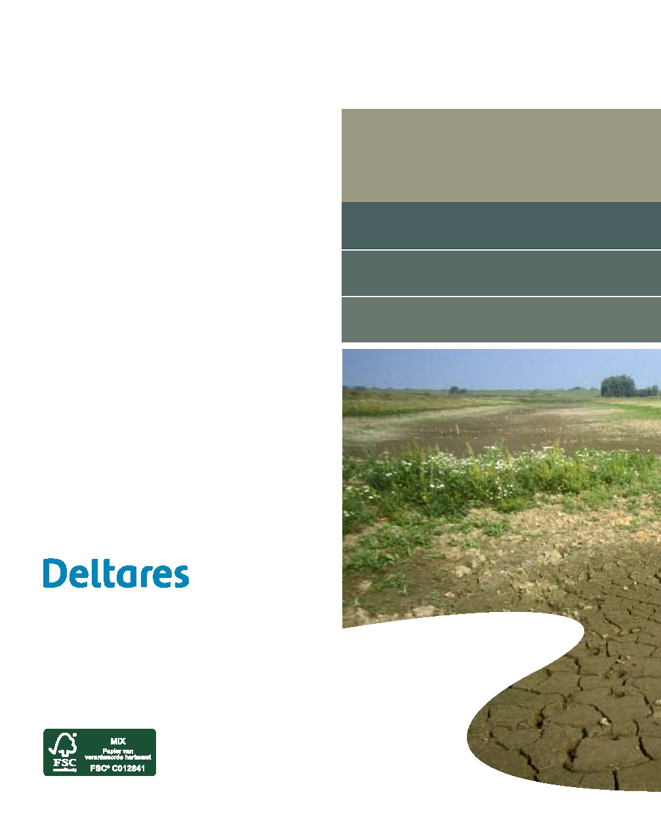
P.O. Box 177
2600 MH Delft
The Netherlands
T +31 (0)88 335 82 73
info@deltares.nl www.deltares.nl

